

Wireless Network
Broadband Router 54G+

WL-527

Full manual

Copyright
The contents of this publication may not be reproduced in any part or as a whole, stored, transcribed in an information retrieval system, translated into any language, or transmitted in any form or by any means, mechanical, magnetic, electronic, optical, photocopying, manual, or otherwise, without the prior written permission.
Trademarks
All products, company, brand names are trademarks or registered trademarks of their respective companies. They are used for identification purpose only. Specifications are subject to be changed without prior notice.

FCC Interference Statement
This equipment has been tested and found to comply with the limits for a Class B digital device pursuant to Part 15 of the FCC Rules. These limits are designed to provide reasonable protection against radio interference in a commercial environment. This equipment can generate, use and radiate radio frequency energy and, if not installed and used in accordance with the instructions in this manual, may cause harmful interference to radio communications. Operation of this equipment in a residential area is likely to cause interference, in which case the user, at his own expense, will be required to take whatever measures are necessary to correct the interference.
CE Declaration of Conformity
This equipment complies with the requirements relating to electromagnetic compatibility, EN 55022/A1 Class B.

The specification is subject to change without notice.
Table of Contents
Chapter 1 Introduction 6
1.1 Features 6
1.2 Minimum Requirements 7
1.3 Package Content 7
Chapter 2 Hardware Installation 8
2.1 Panel Layout 8
2.1.1 Front LEDs 8
2.1.2. Rear Panel 9
2.2 Procedure for Hardware Installation 10
2.2.1 Decide where to place your Wireless Broadband Router 10
2.2.2 Setup LAN connection 10
2.2.3 Setup WAN connection 10
2.2.4 Power on 10
Chapter 3 Network Settings and Software Installation 11
3.1 Make The Correct Network Settings for your PC 11
Chapter 4 Configuring Wireless Broadband Router 13
4.1 Start-up and Log in 14
4.2 Status 15
4.2.1 Device Status 16
4.2.2 Internet Status 17
4.2.3 DHCP Client status 18
4.2.4 System Log 19
4.2.5 Statistics 20
5. Run Setup Wizard 21
Chapter 6 Basic Settings 23
6.1 LAN Settings 23
6.2 WAN Configuration 24
6.2.1 Dynamic IP 25
6.2.2 Static IP Address 25
6.2.3 PPPoE (PPP over Ethernet) 25
6.2.4 PPTP 27
6.2.5 L2TP 28
6.2.6 Telstra Big Pond 28
6.3 DNS 29
Chapter 7 Wireless Settings 30
7.1 Wireless Basic Settings 30
7.2 Advanced Wireless Settings 31
7.3 Wireless Security Options 32
7.3.1 WEP Encryption 32
7.3.2 802.1x only 34
7.3.3 WPA Pre-shared key 35
7.3.4 WPA Radius 36
7.4 Access Control 37
Chapter 8 Firewall Settings 38
8.1 DMZ 38
8.2 DoS Attack 39
8.3 Access Control 40
8.4 URL Block 41
Chapter 9 Advanced Settings 43
9.1 Port Forwarding 43
9.2 Virtual Server 44
9.3 Special Applications 46
9.4 ALG Settings 48
9.5 UpnP Settings 48
9.6 QoS 49
Chapter 10 Tools 52
10.1 Timezone 53
10.2 Remote Management 54
10.3 Firmware Upgrade 55
10.4 Back-up Settings 56
10.5 Reset (restart) the router 56
10.6 DDNS 57
Appendix A 58
Glossary 59

Chapter 1 Introduction
Congratulations on purchasing this Wireless Broadband Router. This Wireless Broadband Router is a cost-effective IP Sharing Router that enables multiple users to share the Internet through an ADSL or cable modem. Simply configure your Internet connection settings in the Wireless Broadband Router and plug your PC to the LAN port and you're ready to share files and access the Internet. As your network grows, you can connect another hub or switch to the router’s LAN ports, allowing you to easily expand your network. The Wireless Broadband Router is embedded with a IEEE 802.11g/b access point that allows you to build up a wireless LAN. The Wireless Broadband Router provides a total solution for the Small and Medium-sized Business (SMB) and the Small Office/Home Office (SOHO) markets, giving you an instant network today, and the flexibility to handle tomorrow's expansion and speed.

1.1 Features
- High Internet Access throughput (50M)
- Allow multiple users to share a single Internet line
- Supports up to 253 users
- Internet Access via Cable or xDSL modem
- Access Private LAN Servers from the Public Network
- Equipped with four LAN ports (10/100M) and one WAN port (10/100M)
- Provides IEEE 802.11g/b wireless LAN access point
- Support DHCP (Server/Client) for easy setup
- Support advance features such as: Special Applications, DMZ, Virtual Servers, Access Control, Firewall.
- Allow you to monitor the router’s status such as: DHCP Client Log, System Log, Security Log and Device/Connection Status
- Easy to use Web-based GUI for configuration and management purposes
- Remote Management allows configuration and upgrades from a remote site (over the Internet)

1.2 Minimum Requirements
- One External xDSL (ADSL) or Cable modem with an Ethernet port (RJ-45)
- Network Interface Card (NIC) for each Personal Computer (PC)
- PCs with a Web-Browser (Internet Explorer 4.0 or higher, or Netscape Navigator 4.7 or higher)

1.3 Package Content
- One 4-port Wireless Broadband router unit
- One Quick Installation Guide
- One User Manual CD
- One Power Adapter
- CAT-5 UTP Fast Ethernet Cable

Note
The WAN “idle timeout” auto-disconnect function may not work due to abnormal activities of some network application software, computer virus or hacker attacks from the Internet. For example, some software sends network packets to the Internet in the background, even when you are not using the Internet. So please turn off your computer when you are not using it. This function also may not work with some ISP. So please make sure this function can work properly when you use this function in the first time, especially your ISP charge you by time used.

Chapter 2 Hardware Installation

2.1 Panel Layout

2.1.1 Front LEDs
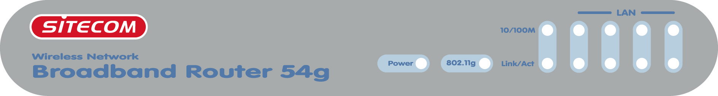
Figure 2-1 Front LEDs

LEDs:
LED | Function | Color | Status | Description
POWER | Power indication | Green | On | Power is being applied to this product.
LNK/ACT | Link Status | Green | On | The corresponding WAN or LAN port is linked.
LNK/ACT | Link Status | Green | Blinking | The corresponding WAN or LAN port is sending or receiving data.
802.11G | Wireless Activity | Green | On | Wireless LAN had been enabled
802.11G | Wireless Activity | Green | Blinking | Sending or receiving data via wireless.
10/100 | Data Rate | Green | Blinking | The corresponding WAN or LAN port is sending or receiving data.
10/100 | Data Rate | Green | On | Data is transmitting in 100Mbps on the corresponding WAN or LAN port.

2.1.2. Rear Panel
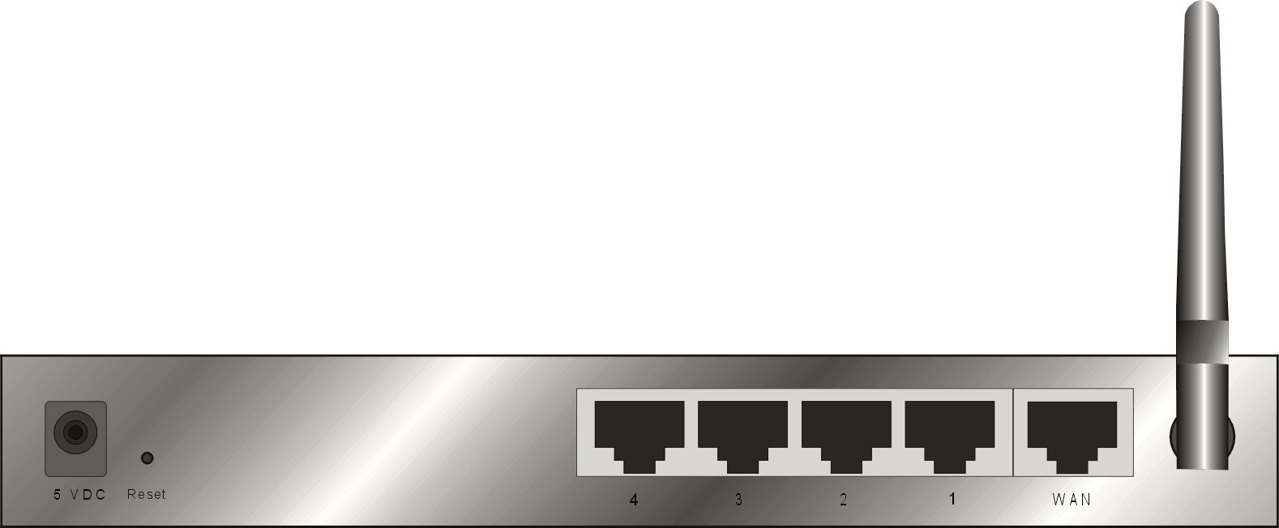
Figure 2-2 Rear Panel
Ports:
Port | Description
PWR | Power inlet
WAN | the port where you will connect your cable (or DSL) modem or Ethernet router.
Port 1-4 | the ports where you will connect networked computers and other devices.
Reset | To reset system settings to factory defaults, press the reset button for at least 4 seconds.  To reboot the device, press the reset button less than 4 seconds.

2.2 Procedure for Hardware Installation

2.2.1 Decide where to place your Wireless Broadband Router
You can place your Wireless Broadband Router on a desk or other flat surface, or you can mount it on a wall. For optimal performance, place your Wireless Broadband Router in the center of your office (or your home) in a location that is away from any potential source of interference, such as a metal wall or microwave oven. This location must be close to power and network connection.

2.2.2 Setup LAN connection
- Wired LAN connection: connects an Ethernet cable from your computer’s Ethernet port to one of the LAN ports of this product.
- Wireless LAN connection: locate this product at a proper position to gain the best transmit performance.
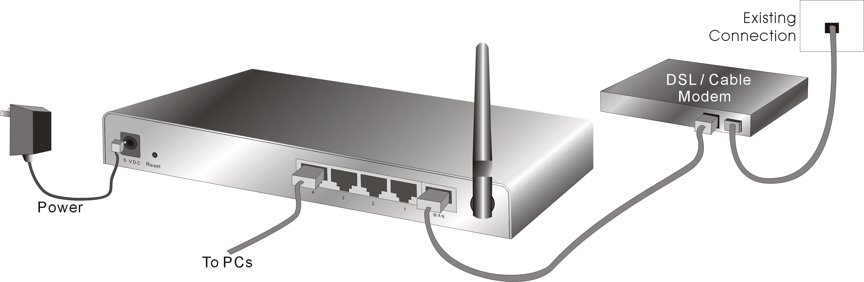
Figure 2-3 Setup of LAN and WAN connections for this product.

2.2.3 Setup WAN connection
Prepare an Ethernet cable for connecting this product to your cable/xDSL modem or Ethernet backbone. Figure 2-3 illustrates the WAN connection.

2.2.4 Power on
Connecting the power cord to power inlet and turning the power switch on, this product will automatically enter the self-test phase. When it is in the self-test phase, the Power LED will not be lighted for about 15 seconds, and then Power will flash 9 times to indicate that the self-test operation has finished. Finally, power will be lit continuously to indicate that this product is in normal operation.

Chapter 3 Network Settings and Software Installation

To use this product correctly, you have to properly configure the network settings of your computers and install the attached setup program into your MS Windows platform (Windows 95/98/NT/2000).

3.1 Make The Correct Network Settings for your PC
The default IP address of this product is 192.168.0.1, and the default subnet mask is 255.255.255.0. These addresses can be changed on your need, but the default values are used in this manual. If the TCP/IP environment of your computer has not yet been configured, you can refer to Appendix A to configure it. For example,
- configure IP as 192.168.0.100, subnet mask as 255.255.255.0 and gateway as 192.168.0.1, or more easier,
- configure your computers to load TCP/IP setting automatically, that is, via DHCP server of this product.
After installing the TCP/IP communication protocol, you can use the ping command to check if your computer has successfully connected to this product. The following example shows the ping procedure for Windows 95 platforms. First, execute the ping command
ping 192.168.0.1
If the following messages appear:

Pinging 192.168.0.1 with 32 bytes of data:

Reply from 192.168.0.1: bytes=32 time=2ms TTL=64
a communication link between your computer and this product has been successfully established. Otherwise, if you get the following messages,

Pinging 192.168.0.1 with 32 bytes of data:

Request timed out.
There must be something wrong in your installation procedure. You have to check the following items in sequence:
- Is the Ethernet cable correctly connected between this product and your computer?
Tip: The LAN LED of this product and the link LED of network card on your computer must be lighted.
- Is the TCP/IP environment of your computers properly configured?
Tip: If the IP address of this product is 192.168.0.1, the IP address of your computer must be 192.168.0.X and default gateway must be 192.168.0.1.

Chapter 4 Configuring Wireless Broadband Router
This product provides Web based configuration scheme, that is, configuring by your Web browser, such as Netscape Communicator or Internet Explorer. This approach can be adopted in any MS Windows, Macintosh or UNIX based platforms.
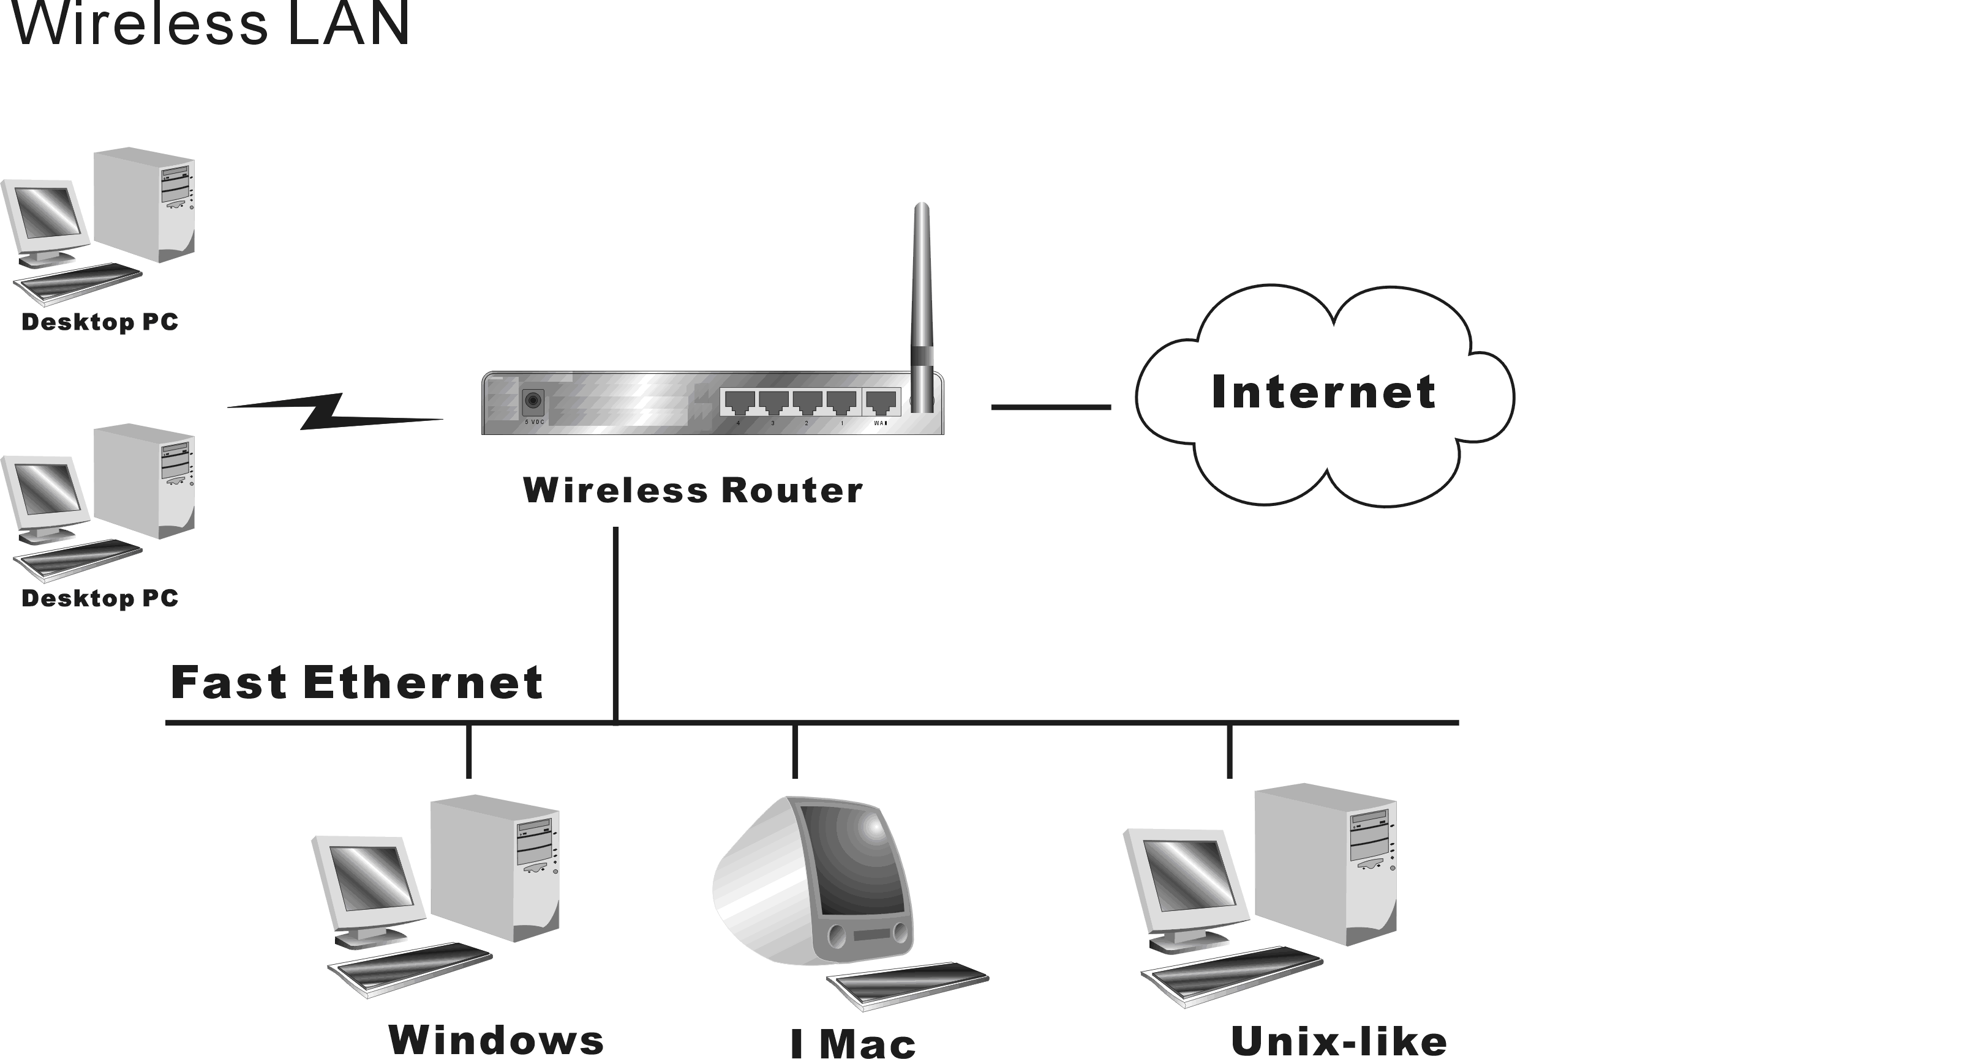

4.1 Start-up and Log in
Activate your browser, and disable the proxy or add the IP address of this product into the exceptions. Then, type this product’s IP address in the Location (for Netscape) or Address (for IE) field and press ENTER. For example: http://192.168.0.1.
After the connection is established, you will see the web user interface of this product. There are two appearances of web user interface: for general users and for system administrator.
To log in as an administrator, enter your login name and password (default: admin/admin) and click OK. If the password is correct, the web appearance will be changed into administrator configure mode. As listed in its main menu, there are several options for system administration.
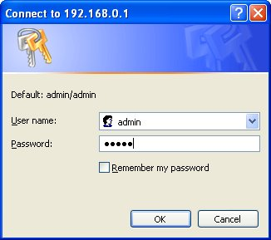

4.2 Status
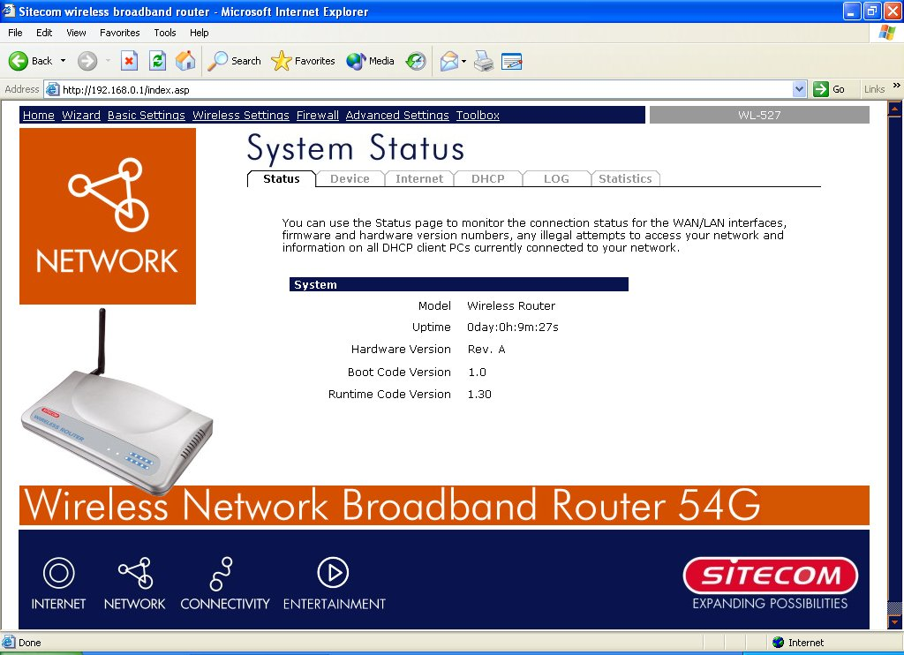
The Status section allows you to monitor the current status of your router. You can use the Status page to monitor: the connection status of the Broadband router's WAN/LAN interfaces, the current firmware and hardware version numbers, any illegal attempts to access your network, and information on all DHCP client PCs currently connected to your network.

Parameters Description
4.2 Status Shows the router’s system information
4.2.1 Device View the Broadband router’s current setting status
4.2.2 Internet View the Broadband router’s current Internet connection status
4.2.3 DHCP View LAN client information currently linked to the DHCP server
4.2.4 Log View the Broadband router’s system log
4.2.5 Statistics Shows the statistics

4.2.1 Device Status
View the Broadband router’s current configuration settings. The Device Status displays the configuration settings you’ve configured in the Wizard/Basic Settings/Wireless Settings section.
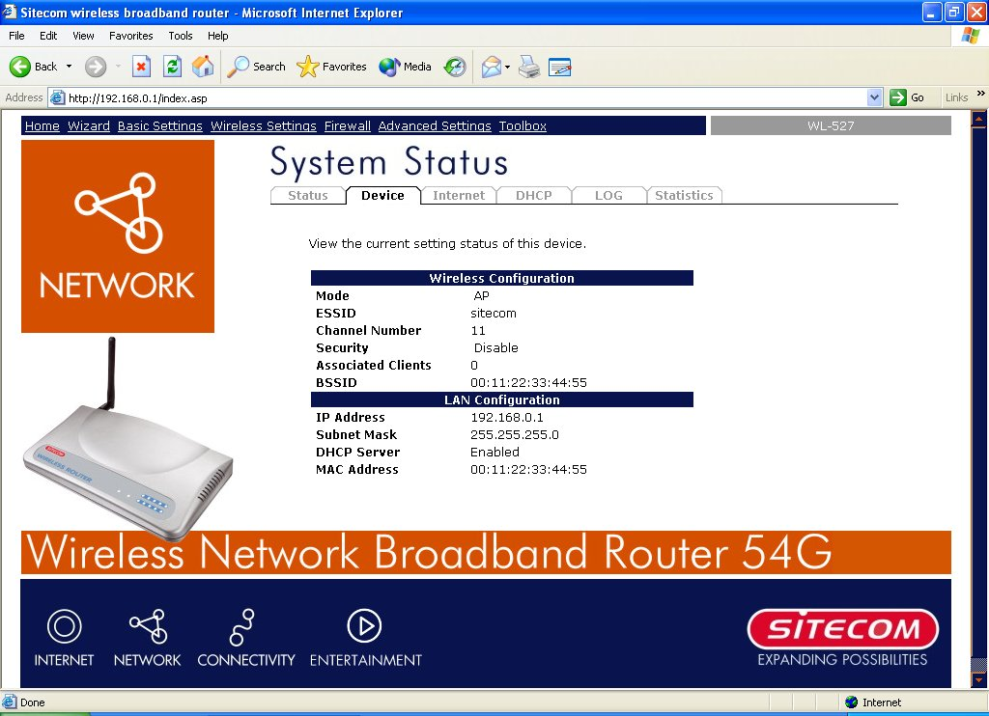
Parameters Description
Device Status This page displays the Broadband router LAN port’s current LAN IP Address and Subnet Mask. It also shows whether the DHCP Server function is enabled/disabled..

4.2.2 Internet Status
View the Broadband router’s current Internet connection status and other related information
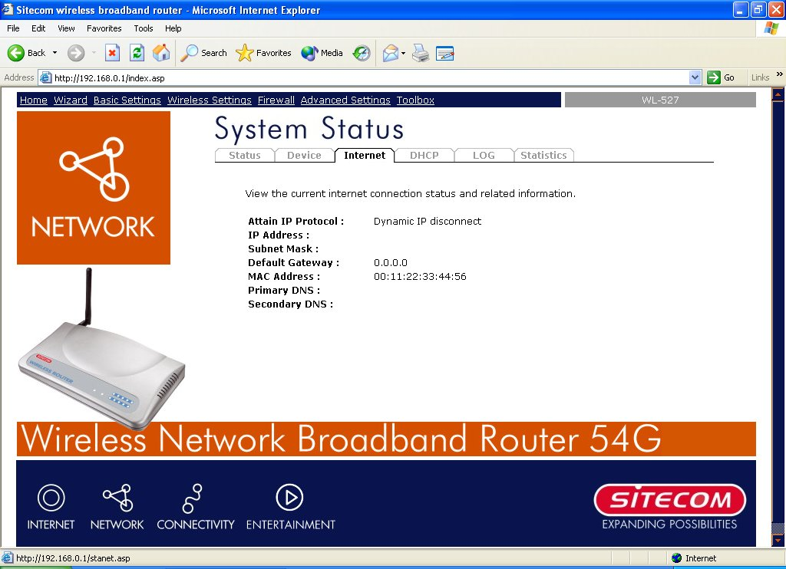

Parameters Description
Internet Connection This page displays whether the WAN port is connected to a Cable/DSL connection. It also displays the router’s WAN port: WAN IP address, Subnet Mask, and ISP Gateway as well as the Primary DNS and Secondary DNS being used.

4.2.3 DHCP Client status
View your LAN client's information that is currently linked to the Broadband router's DHCP server.
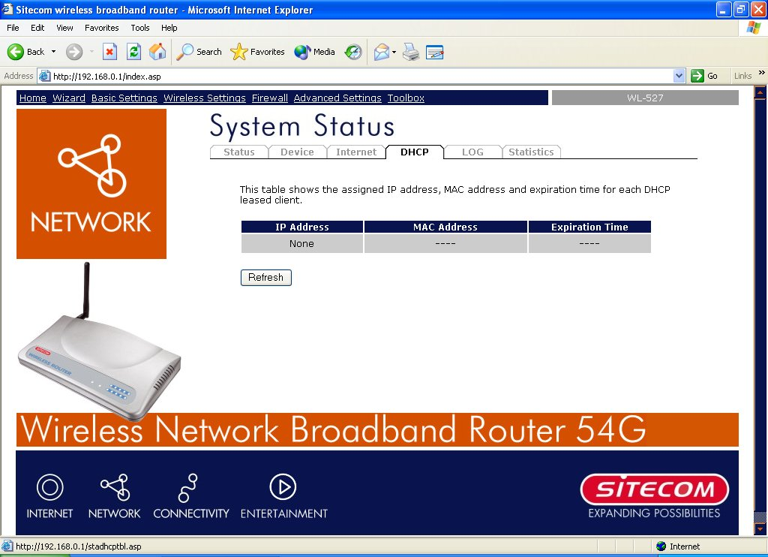
Parameters Description
Active DHCP Client This page shows all DHCP clients (LAN PCs) currently connected to your network. The “Active DHCP Client Table” displays the IP address and the MAC address and Time Expired of each LAN Client. Use the Refresh button to get the most updated situation

4.2.4 System Log
View the operation log of the system.
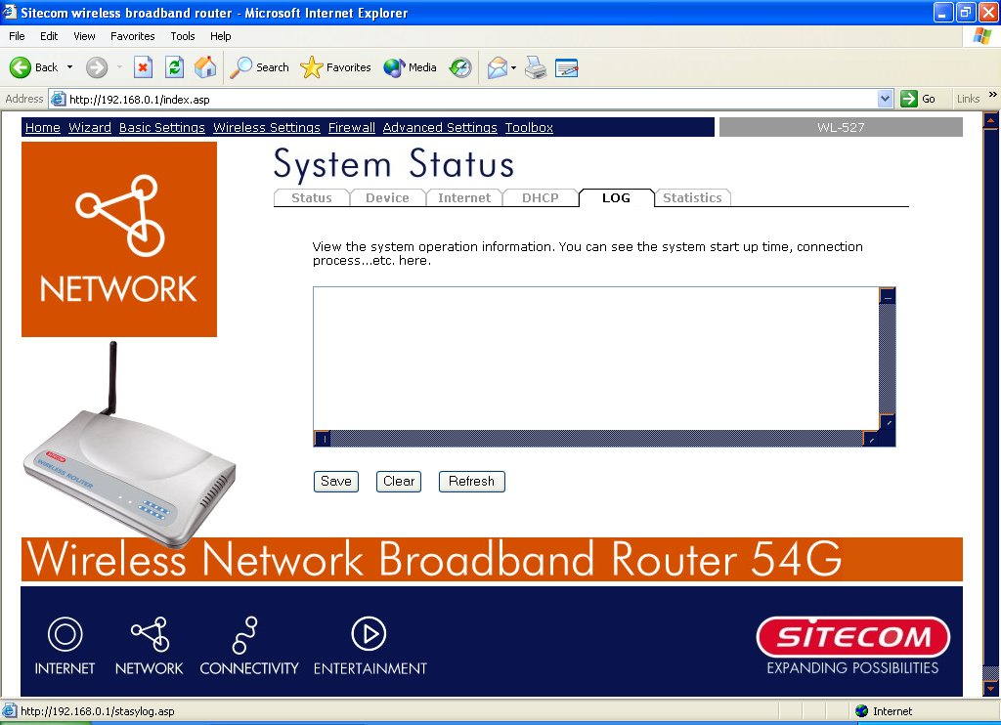
Parameters Description
System Log This page shows the current system log of the Broadband router. It displays any event occurred after system start up.
At the bottom of the page, the system log can be saved <Save> to a local file for further processing or the system log can be cleared <Clear> or it can be refreshed <Refresh> to get the most updated situation. When the system is powered down, the system log will disappear if not saved to a local file.

4.2.5 Statistics
View the statistics of packets sent and received on WAN, LAN and Wireless LAN.
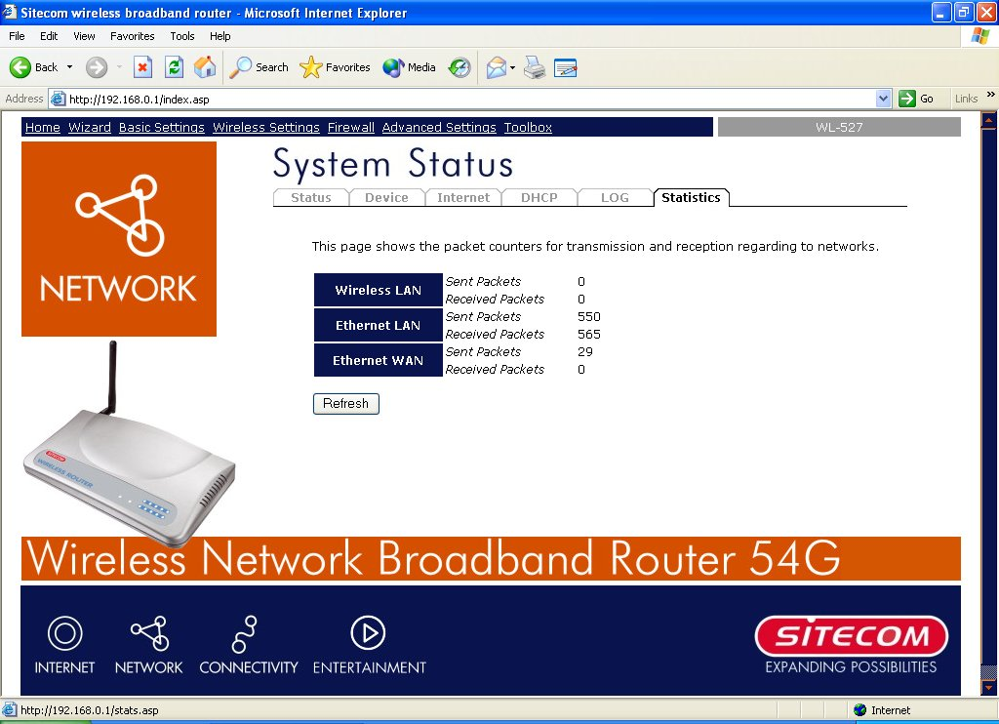

Parameters Description
Statistics Shows the counters of packets sent and received on WAN, LAN and Wireless LAN.

5. Run Setup Wizard
- Click Wizard to configure the router.
- The Setup wizard will now be displayed; check that the modem is connected and click Next.
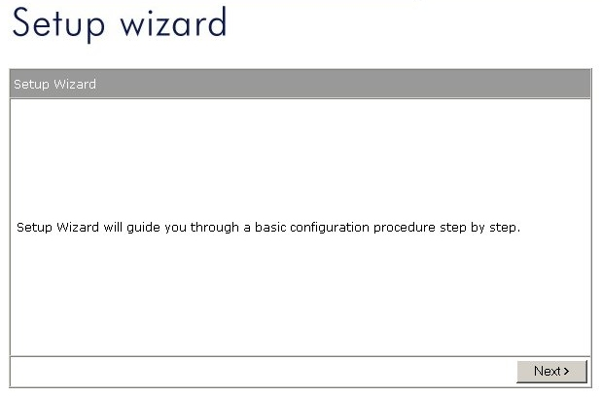
- Select your country from the Country list.
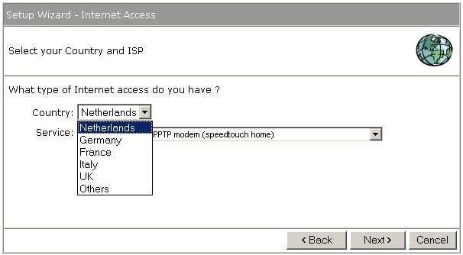
- From Service, select your internet provider. Click Next.
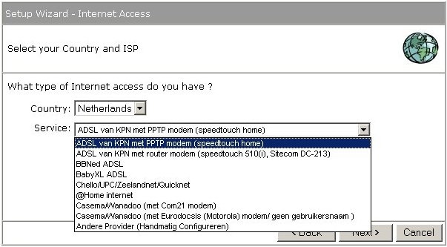

- Depending on the chosen provider, you may need to enter your user name and password, MAC address or hostname in the following window. After you have entered the correct information, click Next.
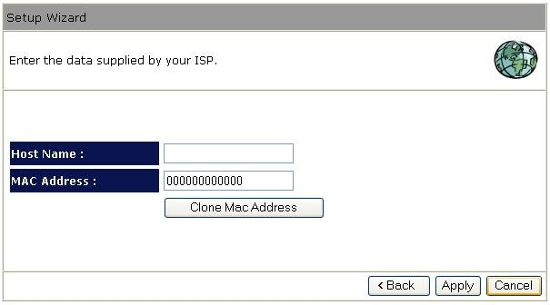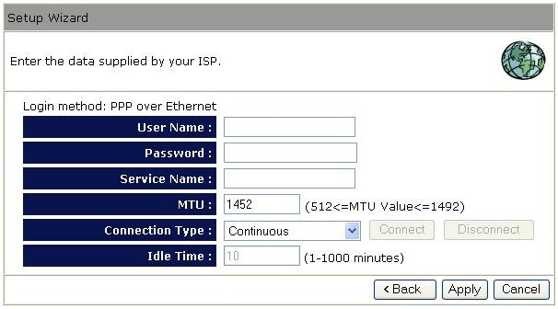
- Click APPLY to complete the configuration.
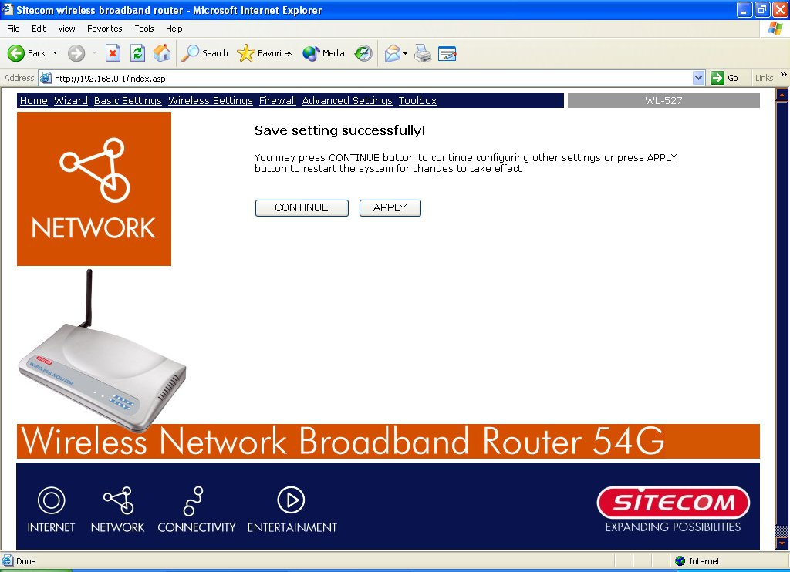
- The router will now save the settings and restart, please wait 30 seconds and you will transferred back to the status window. The configuration is complete.
- Wait for about 10 seconds to allow the router to connect to the Internet.

Chapter 6 Basic Settings

6.1 LAN Settings
The LAN Port screen below allows you to specify a private IP address for your router’s LAN ports as well as a subnet mask for your LAN segment.
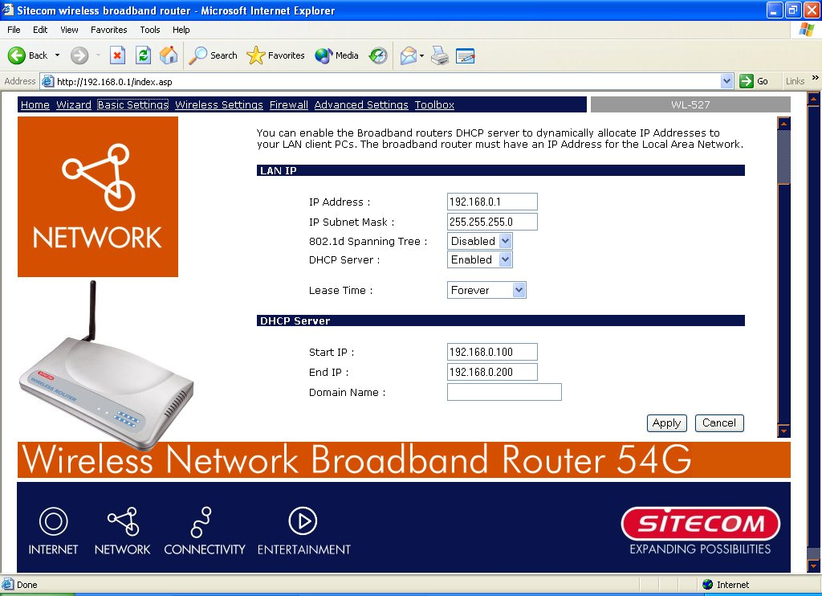

Parameters Default Description
IP address 192.168.0.1 This is the router’s LAN port IP address (Your LAN
clients default gateway IP address)
IP Subnet Mask 255.255.255.0 Specify a Subnet Mask for your LAN segment
802.1d Spanning Tree Disabled If 802.1d Spanning Tree function is enabled, this router will use the spanning tree protocol to prevent network loops.
DHCP Server Enabled You can enable or disable the DHCP server. By
Enabling DHCP server the router will automatically give your LAN clients an IP address.
Lease Time Forever The DHCP when enabled will temporarily give
your LAN clients an IP address. In the Lease Time setting you can specify the time period that the DHCP lends an IP address to your LAN clients. The DHCP will change your LAN client’s IP address when this time threshold period is reached
IP Address Pool You can select a particular IP address range for your DHCP server to issue IP addresses to your LAN Clients.
Note: By default the IP range is from: Start IP 192.168.0.100 to End IP 192.168.0.199. If you want your PC to have a static/fixed IP address then you’ll have to choose an IP address outside this IP address Pool
Domain Name You can specify a Domain Name for your LAN
Click <Apply> at the bottom of the screen to save the above configurations. You can now configure other advance sections or start using the router (with the advance settings in place).

6.2 WAN Configuration
Use the WAN Settings screen if you have already configured the Wizard section and you would like to change your Internet connection type. The WAN Settings screen allows to specify the type of WAN port connect you want to establish with your ISP. The WAN settings offer the following selections for the router’s WAN port, Dynamic IP, Static IP Address, PPPoE, PPTP, L2TP, Telstra Big Pond, DNS and DDNS.
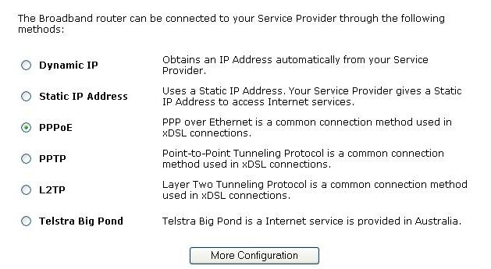
Parameters Description
6.2.1 Dynamic IP address Your ISP will automatically give you an IP address
6.2.2 Static IP address Your ISP has given you an IP address already
6.2.3 PPPoE Your ISP requires PPPoE connection.
6.2.4 PPTP Your ISP requires you to use a Point-to-Point Tunneling Protocol (PPTP) connection.
6.2.5 L2TP Your ISP requires L2TP connection.
6.2.6 Telstra Big Pond Your ISP requires Telstra Big Pond connection.

Once you have made a selection, click <More Configuration> at the bottom of the screen and proceed to the manual’s relevant sub-section

6.2.1 Dynamic IP
Choose the Dynamic IP selection if your ISP will automatically give you an IP address. Some ISP’s may also require that you fill in additional information such as Host Name, Domain Name and MAC address. Your ISP may require a particular MAC address in order for you to connect to the Internet. This MAC address is the PC’s MAC address that your ISP had originally connected your Internet connection to. Type in this MAC address in this section or use the “Clone MAC Address” button to replace the WAN MAC address with the MAC address of that PC (you have to be using that PC for the Clone MAC Address button to work). To find out the PC’s MAC address see Appendix A.

6.2.2 Static IP Address
Select Static IP address if your ISP has given you a specific IP address for you to use. Your ISP should provide all the information required in this section.

6.2.3 PPPoE (PPP over Ethernet)
Select PPPoE if your ISP requires the PPPoE protocol to connect you to the Internet. Your ISP should provide all the information required in this section.
Parameter Description
User Name Enter the User Name provided by your ISP for the PPPoE connection
Password Enter the Password provided by your ISP for the PPPoE connection
Service Name This is optional. Enter the Service name should your ISP requires it, otherwise leave it blank.
MTU This is optional. You can specify the maximum size of your transmission packet to the Internet. Leave it as it is if you to not wish to set a maximum packet size.
Connection Type Select “Continuous”, if the router should always connect to the ISP. If the WAN line breaks down and links again, the router will auto-reconnect to the ISP.
Select “Connect On Demand”, if the router should auto-connect to the ISP when someone want to use the Internet. The router will close the WAN connection if the time period that no one is using the Internet exceeds the “Idle Time”.
Select “Manual”, if the router should only connect to the ISP when you click “Connect” manually from the Web user interface.
Idle Time Specify an idle time threshold (minutes) for the WAN port. This means if no packets have been sent (no one is using the Internet) during this specified period, the router will automatically disconnect the connection with your ISP.
Note: This “idle timeout” function may not work due to abnormal activities of some network application software, computer virus or hacker attacks from the Internet. For example, some software sends network packets to the Internet in the background, even when you are not using the Internet. So please turn off your computer when you are not using it. This function also may not work with some ISP. So please make sure this function can work properly when you use this function in the first time, especially your ISP charge you by time used.

6.2.4 PPTP
Select PPTP if your ISP requires the PPTP protocol to connect you to the Internet. Your ISP should provide all the information required in this section.
Parameter Description
Obtain an IP address The ISP requires you to obtain an IP address by DHCP automatically before connecting to the PPTP server.
Use following IP address The ISP give you a static IP to be used to connect to the PPTP server.
IP Address This is the IP address that your ISP has given you to establish a PPTP connection.
Subnet Mask Enter the Subnet Mask provided by your ISP (255.255.255.0)
Gateway Enter the IP address of the ISP Gateway.
User ID Enter the User Name provided by your ISP for the PPTP connection. Sometimes called a Connection ID or User Name.
Password Enter the Password provided by your ISP for the PPTP connection.
PPTP Gateway If your LAN has a PPTP gateway, then enter that PPTP gateway IP address here. If you do not have a PPTP gateway then enter the ISP’s Gateway IP address above
Connection ID This is the ID given by ISP. This is optional.
BEZEQ-ISRAEL Select this item if you are using the service provided by BEZEQ in Israel.
Connection Type Select “Continuous”, if the router should always connect to the ISP. If the WAN line breaks down and links again, the router will auto-reconnect to the ISP.
Select “Connect On Demand”, if the router should auto-connect to the ISP when someone want to use the Internet. The router will close the WAN connection if the time period that no one is using the Internet exceeds the “Idle Time”.
Select “Manual”, if the router should only connect to the ISP when you click ‘Connect’ manually from the Web user interface.
Idle Time Specify an idle time threshold (minutes) for the WAN port. This means if no packets have been sent throughout this specified period, then the router will automatically disconnect.
Note: This “idle timeout” function may not work due to abnormal activities of some network application software, computer virus or hacker attacks from the Internet. For example, some software sends network packets to the Internet in the background, even when you are not using the Internet. So please turn off your computer when you are not using it. This function also may not work with some ISP. So please make sure this function can work properly when you use this function in the first time, especially your ISP charge you by time used.

6.2.5 L2TP
Select L2TP if your ISP requires the L2TP protocol to connect you to the Internet. Your ISP should provide all the information required in this section.

6.2.6 Telstra Big Pond
Select Telstra Big Pond if your ISP requires the Telstra Big Pond protocol to connect you to the Internet. Your ISP should provide all the information required in this section. Telstra Big Pond protocol is used by the ISP in Australia.

6.3 DNS
A Domain Name System (DNS) server is like an index of IP addresses and Web addresses. If you type a Web address into your browser, such as www.router.com, a DNS server will find that name in its index and the matching IP address. Most ISPs provide a DNS server for speed and convenience. If your Service Provider connects you to the Internet with dynamic IP settings, it is likely that the DNS server IP address is provided automatically. However, if there is a DNS server that you would rather use, you need to specify the IP address of that DNS server here.
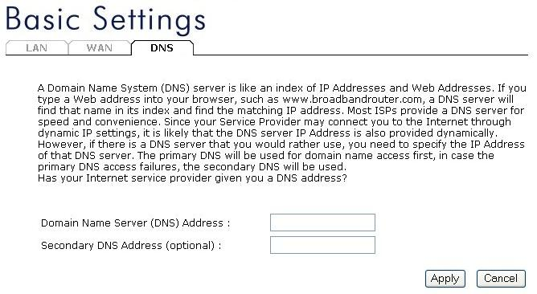
Parameters Description
Domain Name Server (DNS) Server This is the ISP’s DNS server IP address that they gave you; or you can specify your own preferred DNS server IP address
Secondary DNS Address (optional) This is optional. You can enter another DNS server’s IP address as a backup. The secondary DNS will be used should the above DNS fail.

Chapter 7 Wireless Settings

7.1 Wireless Basic Settings
You can set parameters that are used for the wireless stations to connect to this router. The parameters include Mode, ESSID, Channel Number and Associated Client.
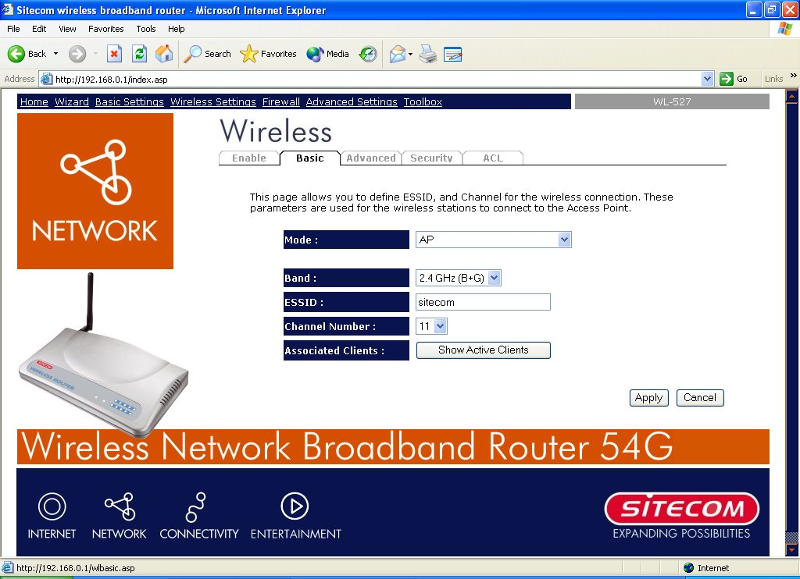
Parameters Description
Mode It allows you to set the AP to AP, Station, Bridge or WDS mode.
Band It allows you to set the AP fix at 802.11b or 802.11g mode. You also can select B+G mode to allow the AP select 802.11b and 802.11g connection automatically.
ESSID This is the name of the wireless LAN. All the devices in the same wireless LAN should have the same ESSID. Default ESSID for this device is: sitecom
Channel Number The channel used by the wireless LAN. All devices in the same wireless LAN should use the same channel.
Associated Clients Click “Show Active Clients” button, then an “Active Wireless Client Table” will pop up. You can see the status of all active wireless stations that are connecting to the access point.
WLAN MAC This is the MAC address used by the Wireless interface of this AP when it is in the station mode.
Clone MAC Click the “Clone MAC” button will copy the MAC address of your PC, that you are using to configure the AP, to the WLAN MAC.
MAC address If you want to bridge more than one networks together with wireless LAN, you have to set this access point to “AP Bridge-Point to Point mode”, “AP Bridge-Point to Multi-Point mode” or “AP Bridge-WDS mode”. You have to enter the MAC addresses of other access points that join the bridging.
Set Security Click the “Set Security” button, then a “WDS Security Settings” will pop up. You can set the security parameters used to bridge access points together here when your AP is in AP Bridge modes.

7.2 Advanced Wireless Settings
You can set advanced wireless LAN parameters of this router. The parameters include Authentication Type, Fragment Threshold, RTS Threshold, Beacon Interval, Preamble Type. You should not change these parameters unless you know what effect the changes will have on this router.
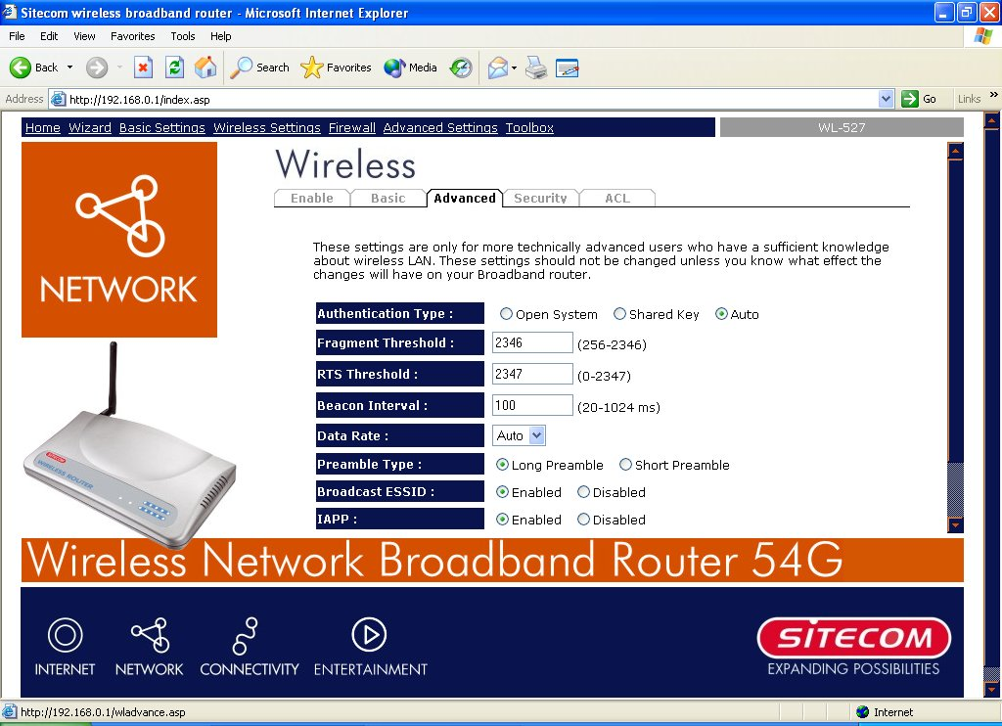
Parameters Description
Authentication Type There are two authentication types: "Open System" and "Shared Key". When you select "Open System", wireless stations can associate with this wireless router without WEP encryption. When you select "Shared Key", you should also setup WEP key in the "Encryption" page and wireless stations should use WEP encryption in the authentication phase to associate with this wireless router. If you select "Auto", the wireless client can associate with this wireless router by using any one of these two authentication types.

Fragment Threshold "Fragment Threshold" specifies the maximum size of a packet during the fragmentation of data to be transmitted. If you set this value too low, it will result in bad performance.
RTS Threshold When the packet size is smaller the RTS threshold, the wireless router will not use the RTS/CTS mechanism to send this packet.
Beacon Interval The interval of time that this wireless router broadcast a beacon. Beacon is used to synchronize the wireless network.
Data Rate The “Data Rate” is the rate this access point uses to transmit data packets. The access point will use the highest possible selected transmission rate to transmit the data packets.
Preamble Type The “Long Preamble” can provide better wireless LAN compatibility while the “Short Preamble” can provide better wireless LAN performance.
Broadcast ESSID If you enable “Broadcast ESSID”, every wireless station located within the coverage of this access point can discover this access point easily. If you are building a public wireless network, enabling this feature is recommended. Disabling “Broadcast ESSID” can provide better security.
IAPP If you enable “IAPP”, it will allow wireless station roaming between IAPP enabled access points within the same wireless LAN.
802.11g Protection This is also called CTS Protection. It is recommended to enable the protection mechanism. This mechanism can decrease the rate of data collision between 802.11b and 802.11g wireless stations. When the protection mode is enabled, the throughput of the AP will be a little lower due to many of frame traffic should be transmitted.
Click <Apply> at the bottom of the screen to save the above configurations. You can now configure other advance sections or start using the router.

7.3 Wireless Security Options
This Access Point provides complete wireless LAN security functions, include WEP, IEEE 802.11x, IEEE 802.11x with WEP, WPA with pre-shared key and WPA with RADIUS. With these security functions, you can prevent your wireless LAN from illegal access. Please make sure your wireless stations use the same security function.

7.3.1 WEP Encryption
When you select 64-bit or 128-bit WEP key, you have to enter WEP keys to encrypt data. You can generate the key by yourself and enter it. You can enter four WEP keys and select one of them as default key. Then the router can receive any packets encrypted by one of the four keys
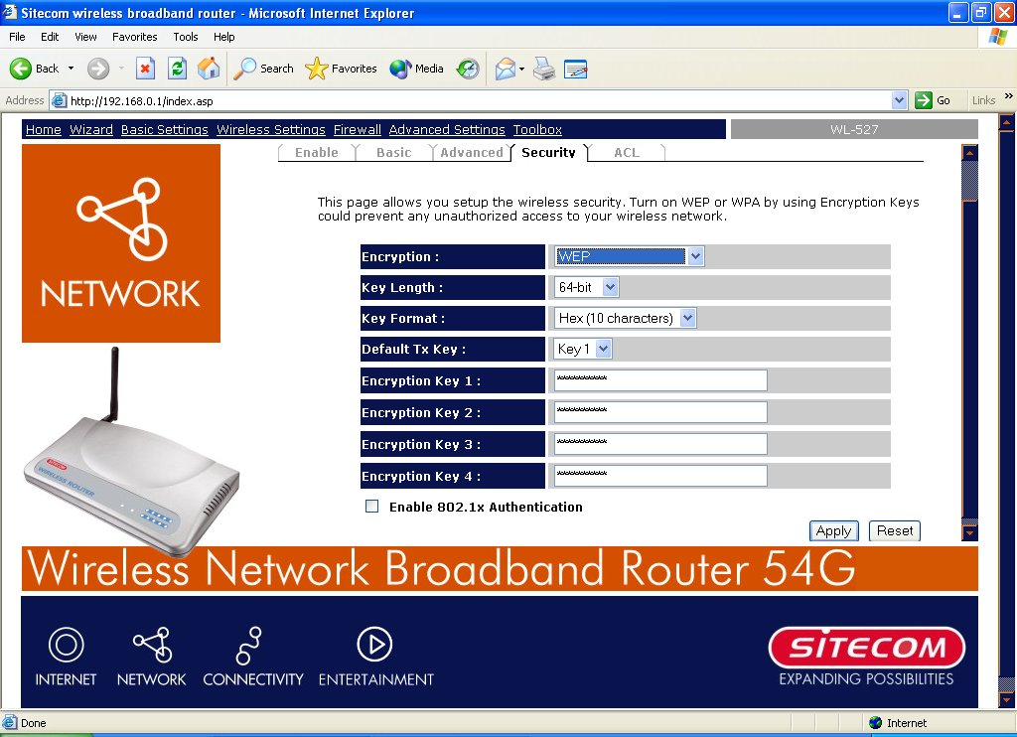
Parameters Description
Key Length You can select the WEP key length for encryption, 64-bit or 128-bit. Larger WEP key length will provide higher level of security, but the throughput will be lower.
Key Format You may select to select ASCII Characters (alphanumeric format) or Hexadecimal Digits (in the "A-F", "a-f" and "0-9" range) to be the WEP Key.
For example: ASCII Characters: guest
Hexadecimal Digits: 12345abcde
Default Key Select one of the four keys to encrypt your data. Only the key you select it in the "Default key" will take effect.
Key1 - Key4 The WEP keys are used to encrypt data transmitted in the wireless network. Fill the text box by following the rules below.
64-bit WEP: input 10-digit Hex values (in the "A-F", "a-f" and "0-9" range) or 5-digit ASCII character as the encryption keys.
128-bit WEP: input 26-digit Hex values (in the "A-F", "a-f" and "0-9" range) or 13-digit ASCII characters as the encryption keys.
Click <Apply> at the bottom of the screen to save the above configurations. You can now configure other advance sections or start using the router (with the advance settings in place)

7.3.2 802.1x only
IEEE 802.1x is an authentication protocol. Every user must use a valid account to login to this Access Point before accessing the wireless LAN. The authentication is processed by a RADIUS server. This mode only authenticates users by IEEE 802.1x, but it does not encrypt the data during communication.
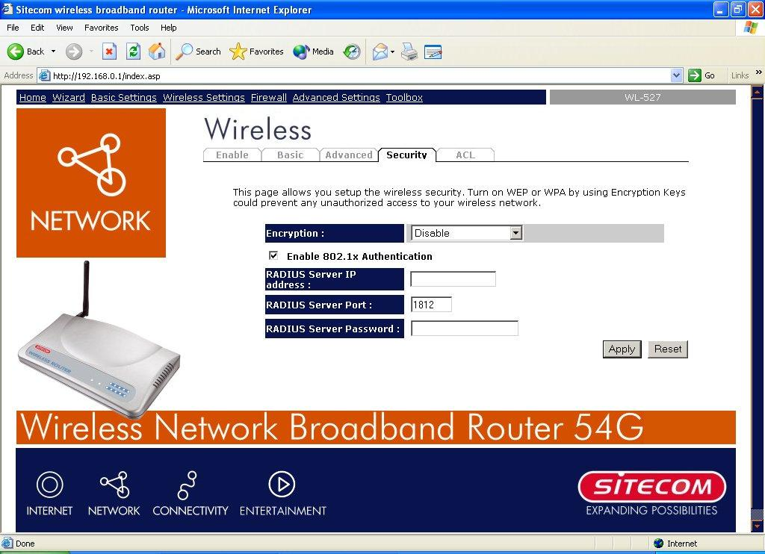
Parameters Description
RADIUS Server IP address The IP address of external RADIUS server.
RADIUS Server Port The service port of the external RADIUS server.
RADIUS Server Password The password used by external RADIUS server.
Click <Apply> at the bottom of the screen to save the above configurations. You can now configure other advance sections or start using the router (with the advance settings in place)

7.3.3 WPA Pre-shared key
Wi-Fi Protected Access (WPA) is an advanced security standard. You can use a pre-shared key to authenticate wireless stations and encrypt data during communication. It uses TKIP or CCMP(AES) to change the encryption key frequently. So the encryption key is not easy to be broken by hackers. This can improve security very much.
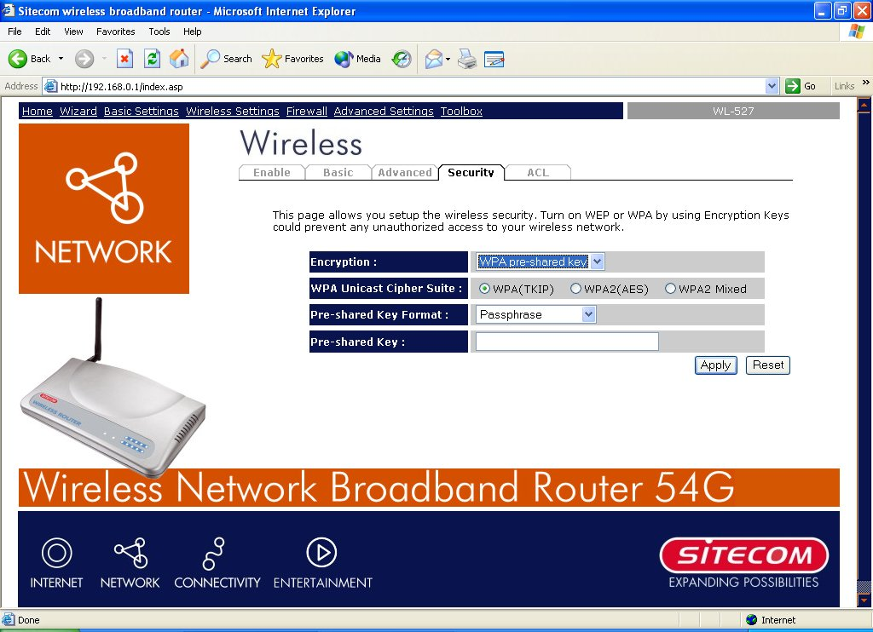
Parameters Description
WPA(TKIP) TKIP can change the encryption key frequently to enhance the wireless LAN security.
WPA2(AES) This use CCMP protocol to change encryption key frequently. AES can provide high level encryption to enhance the wireless LAN security.

WPA2 Mixed This will use TKIP or AES based on the other communication peer automatically.
Pre-shared Key Format You may select to select Passphrase (alphanumeric format) or Hexadecimal Digits (in the “A-F”, “a-f” and “0-9” range) to be the Pre-shared Key. For example: Passphrase: iamguest
Hexadecimal Digits: 12345abcde
Pre-shared Key The Pre-shared key is used to authenticate and encrypt data transmitted in the wireless network. Fill the text box by following the rules below. Hex WEP: input 64-digit Hex values (in the “A-F”, “a-f” and “0-9” range) or at least 8 character pass phrase as the pre-shared keys.

7.3.4 WPA Radius
Wi-Fi Protected Access (WPA) is an advanced security standard. You can use an external RADIUS server to authenticate wireless stations and provide the session key to encrypt data during communication. It uses TKIP or CCMP(AES) to change the encryption key frequently. This can improve security very much.
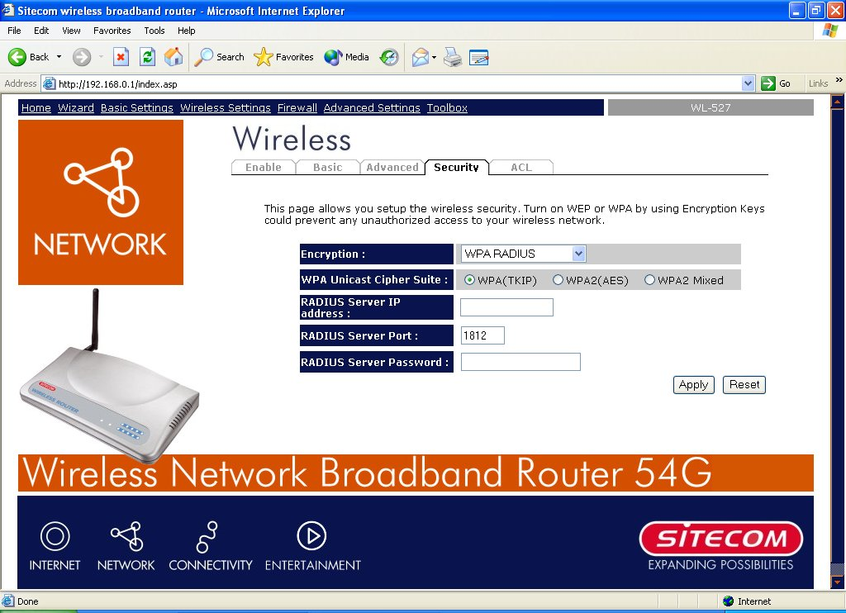
Parameters Description
WPA(TKIP) TKIP can change the encryption key frequently to enhance the wireless LAN security.
WPA2(AES) This use CCMP protocol to change encryption key frequently. AES can provide high level encryption to enhance the wireless LAN security.
WPA2 Mixed This will use TKIP or AES based on the other communication peer automatically.
RADIUS Server IP address The IP address of external RADIUS server.
RADIUS Server Port The service port of the external RADIUS server.
RADIUS Server Password The password used by external RADIUS server.
Click <Apply> at the bottom of the screen to save the above configurations. You can now configure other advance sections or start using the router (with the advance settings in place)

7.4 Access Control
This wireless router provides MAC Address Control, which prevents the unauthorized MAC Addresses from accessing your wireless network.
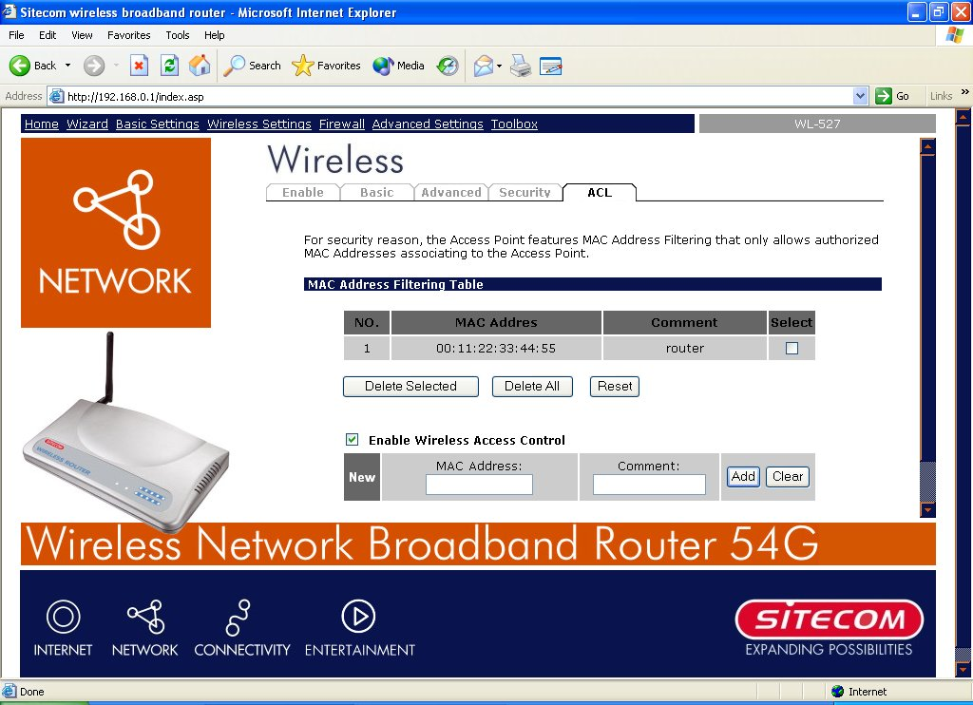
Parameters Description
Enable wireless access control Enable wireless access control
Add MAC address into the list Fill in the "MAC Address" and "Comment" of the wireless station to be added and then click "Add". Then this wireless station will be added into the "Current Access Control List" below. If you find any issues before adding it and want to retype again. Just click "Clear" and both "MAC Address" and "Comment" fields will be cleared.
Remove MAC address from the list If you want to remove some MAC address from the "Current Access Control List ", select the MAC addresses you want to remove in the list and then click "Delete Selected". If you want remove all MAC addresses from the table, just click "Delete All" button. Click "Reset" will clear your current selections.
Click <Apply> at the bottom of the screen to save the above configurations. You can now configure other advance sections or start using the router (with the advance settings in place)

Chapter 8 Firewall Settings
The Broadband router provides extensive firewall protection by restricting connection parameters, thus limiting the risk of hacker attack, and defending against a wide array of common Internet attacks. However, for applications that require unrestricted access to the Internet, you can configure a specific client/server as a Demilitarized Zone (DMZ).
Note: To enable the Firewall settings select Enable and click Apply

8.1 DMZ
If you have a local client PC that cannot run an Internet application (e.g. Games) properly from behind the NAT firewall, then you can open the client up to unrestricted two-way Internet access by defining a DMZ Host. The DMZ function allows you to re-direct all packets going to your WAN port IP address to a particular IP address in your LAN. The difference between the virtual server and the DMZ function is that the virtual server re-directs a particular service/Internet application (e.g. FTP, websites) to a particular LAN client/server, whereas DMZ re-directs all packets (regardless of services) going to your WAN IP address to a particular LAN client/server.
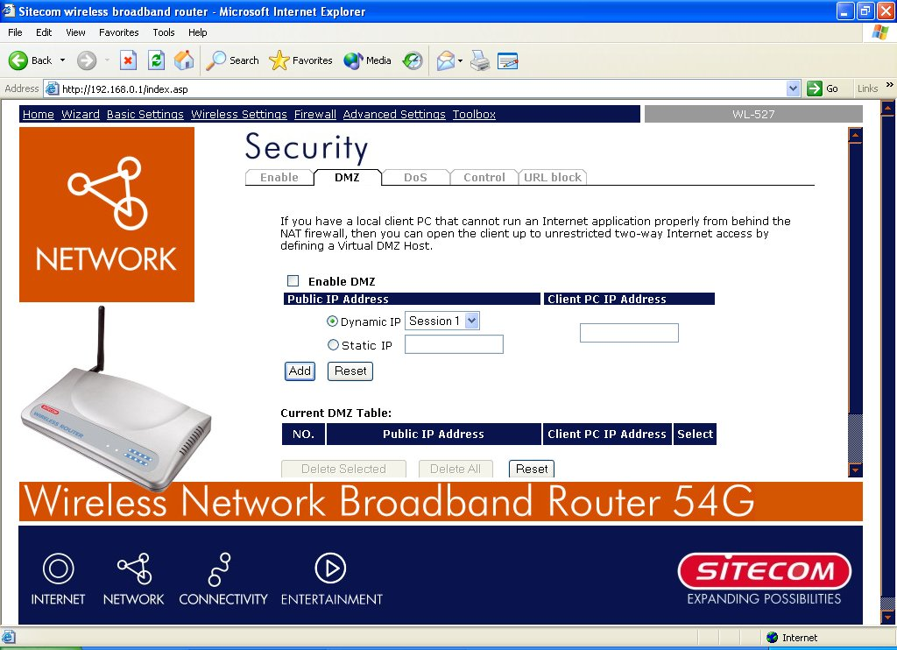
Parameters Description
Enable DMZ Enable/disable DMZ
Note: If there is a conflict between the Virtual Server and the DMZ setting, then Virtual Server function will have priority over the DMZ function.
Public IP Address The IP address of the WAN port or any other Public IP addresses given to you by your ISP
Client PC IP Address Input the IP address of a particular host in your LAN that will receive all the packets originally going to the WAN port/Public IP address above
Note: You need to give your LAN PC clients a fixed/static IP address for DMZ to work properly.
You can now configure other advance sections or start using the router (with the advance settings in place)

8.2 DoS Attack
The Broadband router's firewall can block common hacker attacks, including Denial of Service, Ping of Death, Port Scan and Sync Flood. If Internet attacks occur the router can log the events.
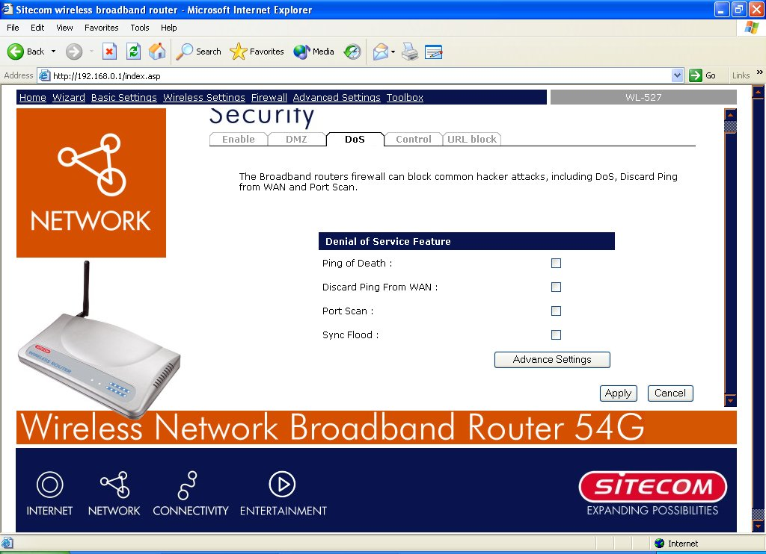
Parameters Description
Ping of Death Protections from Ping of Death attack
Discard Ping From WAN The router’s WAN port will not respond to any Ping requests
Port Scan Protection the router from Port Scan.
Sync Flood Protection the router from Sync Flood attack.
Click <Apply> at the bottom of the screen to save the above configurations. You can now configure other advance sections or start using the router (with the advance settings in place)

8.3 Access Control
If you want to restrict users from accessing certain Internet applications/services (e.g. Internet websites, email, FTP etc.), then this is the place to set that configuration. Access Control allows users to define the traffic type permitted in your LAN. You can control which PC client can have access to these services.
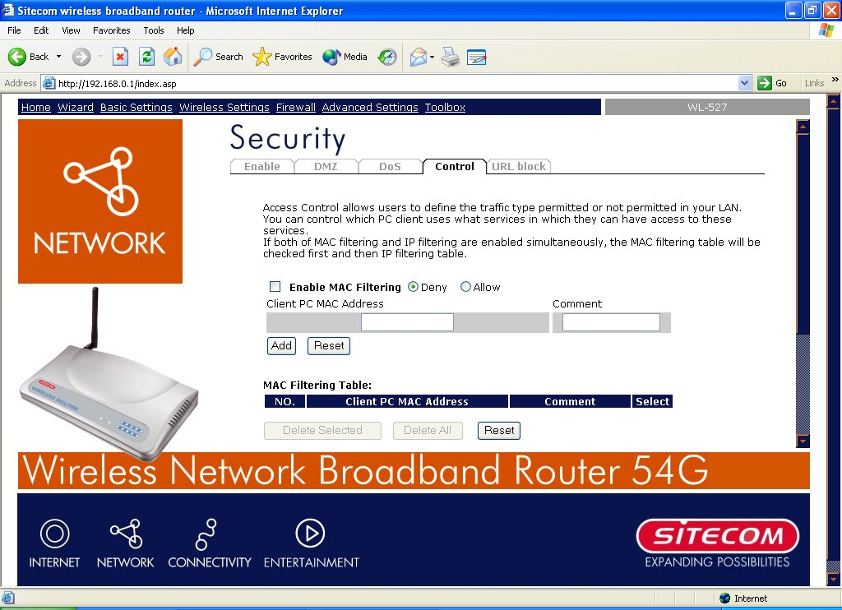
Parameters Description
Deny If you select “Deny” then all PCs will be allowed to access Internet accept for the PCs in the list below.
Allow If you select “Allow” then all PCs will be denied to access Internet accept for the PCs in the list below.
Filter client PCs by IP Fill in “IP Filtering Table” to filter PC clients by IP.
Add PC You can click Add PC to add an access control rule for users by IP addresses.
Remove PC If you want to remove some PC from the "IP Filtering Table", select the PC you want to remove in the table and then click "Delete Selected". If you want remove all PCs from the table, just click "Delete All" button.
Filter client PC by MAC Check “Enable MAC Filtering” to enable MAC Filtering.
Add PC Fill in “Client PC MAC Address” and “Comment” of the PC that is allowed to access the Internet, and then click “Add”. If you find any typo before adding it and want to retype again, just click "Reset" and the fields will be cleared.
Remove PC If you want to remove some PC from the "MAC Filtering Table", select the PC you want to remove in the table and then click "Delete Selected". If you want to remove all PCs from the table, just click the "Delete All" button. If you want to clear the selection and re-select again, just click “Reset”.
You can now configure other advance sections or start using the router (with the advance settings in place)

8.4 URL Block
You can block access to some Web sites from particular PCs by entering a full URL address or just keyword of the Web site.
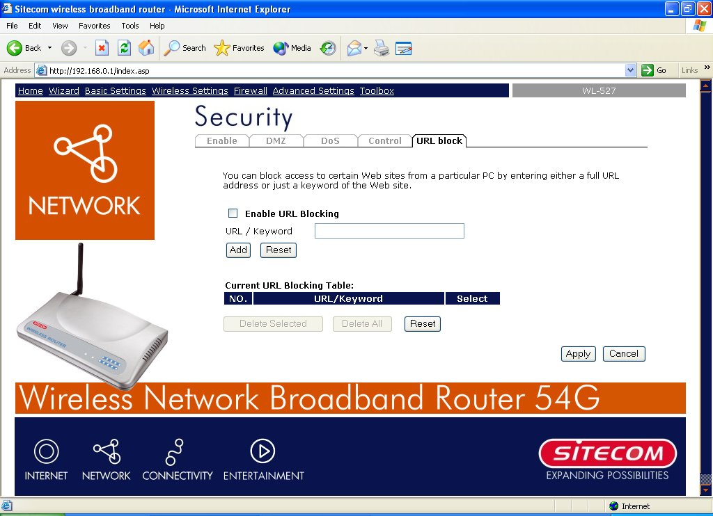
Parameters Description
Enable URL Blocking Enable/disable URL Blocking

Add URL Keyword Fill in “URL/Keyword” and then click “Add”. You can enter the full URL address or the keyword of the web site you want to block. If you find any typo before adding it and want to retype again, just click "Reset" and the field will be cleared.

Remove URL Keyword If you want to remove some URL keyword from the "Current URL Blocking Table", select the URL keyword you want to remove in the table and then click "Delete Selected". If you want remove all URL keyword from the table, just click "Delete All" button. If you want to clear the selection and re-select again, just click “Reset”.
You can now configure other advance sections or start using the router (with the advance settings in place)

Chapter 9 Advanced Settings
Network Address Translation (NAT) allows multiple users at your local site to access the Internet through a single Public IP Address or multiple Public IP Addresses. NAT provides Firewall protection from hacker attacks and has the flexibility to allow you to map Private IP Addresses to Public IP Addresses for key services such as Websites and FTP. Select Disable to disable the NAT function.
Note: If you disable the NAT function, it’s only possible to access the internet from one PC at a time.

9.1 Port Forwarding
The Port Forwarding allows you to re-direct a particular range of service port numbers (from the Internet/WAN Ports) to a particular LAN IP address. It help you to host some servers behind the router NAT firewall.
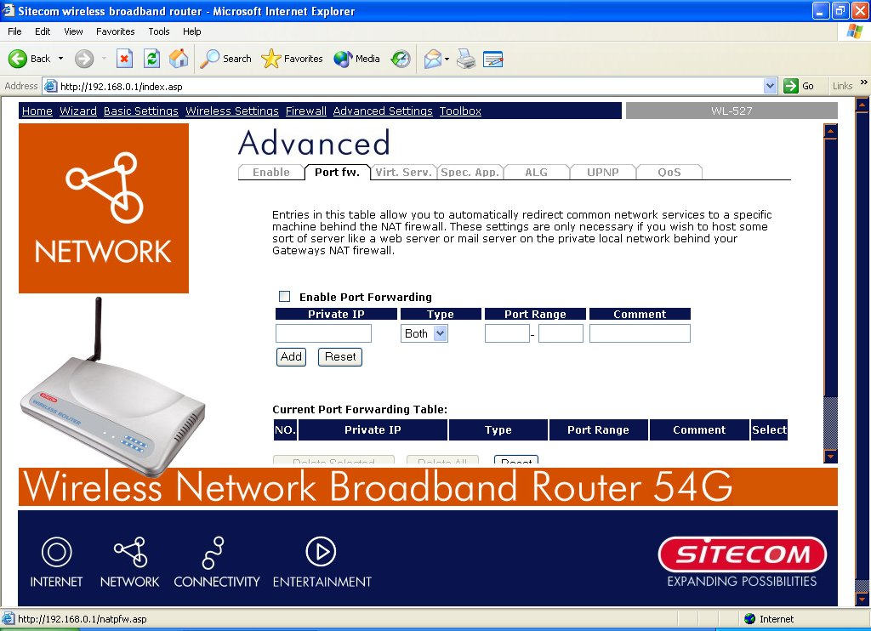
Parameter Description
Enable Port Forwarding Enable Port Forwarding
Private IP This is the private IP of the server behind the NAT firewall.
Note:You need to give your LAN PC clients a fixed IP address for Port Forwarding to work properly.

Type This is the protocol type to be forwarded. You can choose to forward “TCP” or “UDP” packets only or select “both” to forward both “TCP” and “UDP” packets.
Port Range The range of ports to be forward to the private IP.
Comment The description of this setting.
Add Port Forwarding Fill in the "Private IP", “Type”, “Port Range” and "Comment" of the setting to be added and then click "Add". Then this Port Forwarding setting will be added into the "Current Port Forwarding Table" below. If you find any typo before adding it and want to retype again, just click "Clear" and the fields will be cleared.
Remove Port Forwarding If you want to remove some Port Forwarding settings from the " Current Port Forwarding Table", select the Port Forwarding settings you want to remove in the table and then click "Delete Selected". If you want remove all Port Forwarding settings from the table, just click "Delete All" button. Click "Reset" will clear your current selections.

9.2 Virtual Server
Use the Virtual Server function when you want different servers/clients in your LAN to handle different service/Internet application type (e.g. Email, FTP, Web server etc.) from the Internet. Computers use numbers called port numbers to recognize a particular service/Internet application type. The Virtual Server allows you to re-direct a particular service port number (from the Internet/WAN Port) to a particular LAN private IP address and its service port number. (See Glossary for an explanation on Port number)
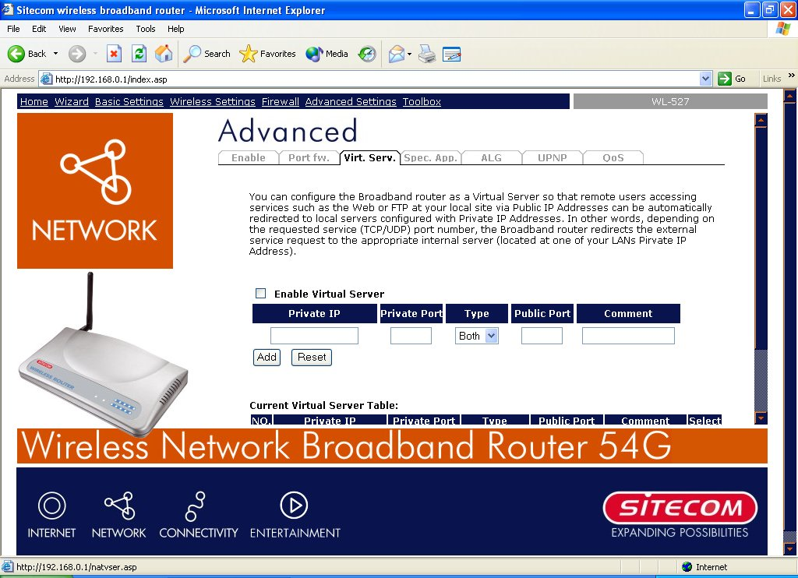
Parameters Description
Enable Virtual Server Enable Virtual Server.
Private IP This is the LAN client/host IP address that the Public Port number packet will be sent to.
Note: You need to give your LAN PC clients a fixed/static IP address for Virtual Server to work properly.
Private Port This is the port number (of the above Private IP host) that the below Public Port number will be changed to when the packet enters your LAN (to the LAN Server/Client IP)
Type Select the port number protocol type (TCP, UDP or both). If you are unsure, then leave it to the default both protocol.
Public Port Enter the service (service/Internet application) port number from the Internet that will be re-directed to the above Private IP address host in your LAN
Note: Virtual Server function will have priority over the DMZ function if there is a conflict between the Virtual Server and the DMZ settings.
Comment The description of this setting.
Add Virtual Server Fill in the "Private IP", "Private Port", "Type", “Public Port” and "Comment" of the setting to be added and then click "Add". Then this Virtual Server setting will be added into the "Current Virtual Server Table" below. If you find any typo before adding it and want to retype again, just click "Clear" and the fields will be cleared.
Remove Virtual Server If you want to remove some Virtual Server settings from the " Current Virtual Server Table", select the Virtual Server settings you want to remove in the table and then click "Delete Selected". If you want remove all Virtual Server settings from the table, just click "Delete All" button. Click "Reset" will clear your current selections.
Click <Apply> at the bottom of the screen to save the above configurations. You can now configure other advance sections or start using the router (with the advance settings in place)

9.3 Special Applications
Some applications require multiple connections, such as Internet games, video conferencing, Internet telephony and others. In this section you can configure the router to support multiple connections for these types of applications.
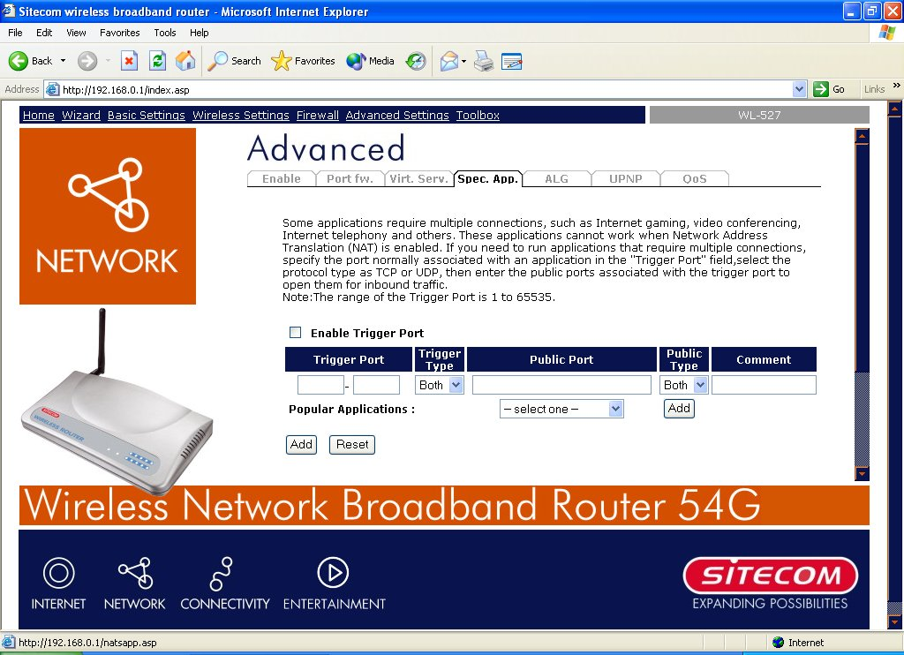
Parameters Description
Enable Trigger Port Enable the Special Application function.
Trigger Port This is the out going (Outbound) range of port numbers for this particular application.
Trigger Type Select whether the outbound port protocol is “TCP”, “UDP” or both.
Public Port Enter the In-coming (Inbound) port or port range for this type of application (e.g. 2300-2400, 47624)
Note: Individual port numbers are separated by a comma (e.g. 47624, 5775, 6541 etc.). To input a port range use a “dash” to separate the two port number range (e.g. 2300-2400)
Public Type Select the Inbound port protocol type: “TCP”, “UDP” or both
Comment The description of this setting.
Popular applications This section lists the more popular applications that require multiple connections. Select an application from the Popular Applications selection. Once you have selected an application, select a location (1-10) in the Copy to selection box and then click the Copy to button. This will automatically list the Public Ports required for this popular application in the location (1-10) you’d specified.
Add Special Application Fill in the "Trigger Port", "Trigger Type”, “Public Port”, "Public Type", "Public Port" and "Comment" of the setting to be added and then click "Add". Then this Special Application setting will be added into the "Current Trigger-Port Table" below. If you find any typo before adding it and want to retype again, just click "Clear" and the fields will be cleared.
Remove If you want to remove some Special Application settings from the " Current Trigger-Port Table", select the Special Application settings you want to remove in the table and then click "Delete Selected". If you want remove all Special Appliacation settings from the table, just click "Delete All" button. Click "Reset" will clear your current selections.
Example: Special Applications
If you need to run applications that require multiple connections, then specify the port (outbound) normally associated with that application in the "Trigger Port" field. Then select the protocol type (TCP or UDP) and enter the public ports associated with the trigger port to open them up for inbound traffic.
Example:
ID | Trigger Port | Trigger Type | Public Port | Public Type | Comment
1 | 28800 | UDP | 2300-2400, 47624 | TCP | MSN Game Zone
2 | 6112 | UDP | 6112 | UDP | Battle.net
In the example above, when a user trigger’s port 28800 (outbound) for MSN Game Zone then the router will allow incoming packets for ports 2300-2400 and 47624 to be directed to that user. Note: Only one LAN client can use a particular special application at a time.

9.4 ALG Settings
You can select applications that need “Application Layer Gateway” to support.
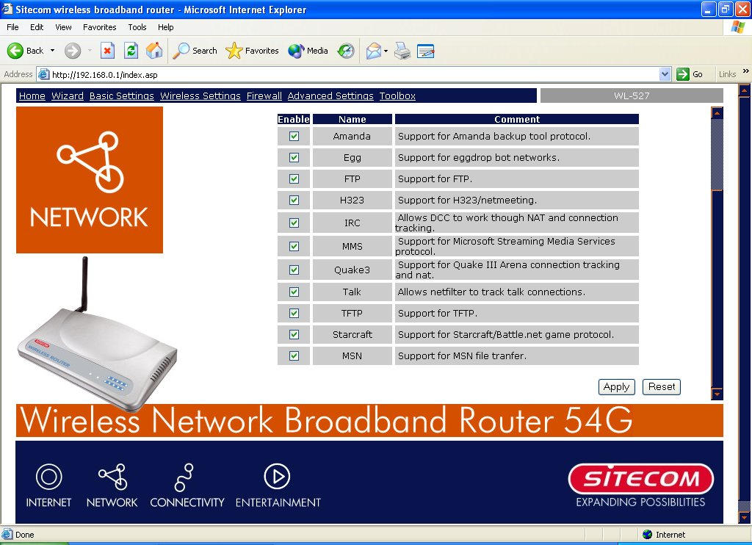
Parameters Description
Enable You can select to enable “Application Layer Gateway”, then the router will let that application correctly pass though the NAT gateway.

9.5 UpnP Settings
With UPnP, all PCs in you Intranet will discover this router automatically. So you do not have to do any configuration for your PC and can access the Internet through this router easily.
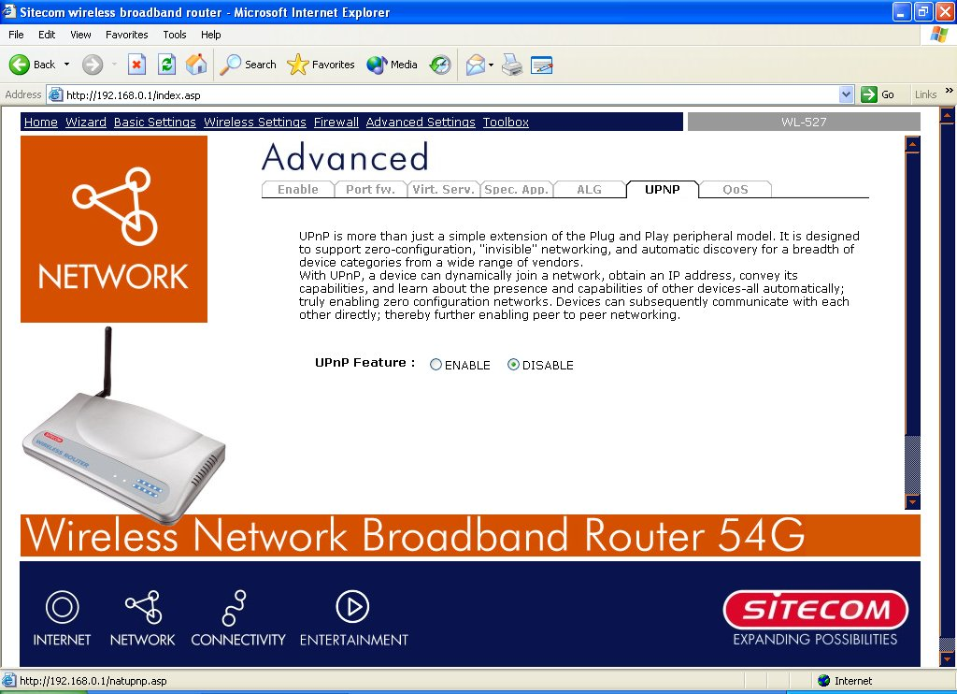
Parameters Default Description
UPnP Feature Disable You can Enable or Disable UPnP feature here. After you enable the UPnP feature, all client systems that support UPnP, like Windows XP, can discover this router automatically and access the Internet through this router without any configuration. The NAT Traversal function provided by UPnP can let applications that support UPnP smoothly connect to Internet sites without any incompatibility problem due to the NAPT port translation.

9.6 QoS
The QoS can let you classify Internet application traffic by source/destination IP address and port number. You can assign priority for each type of application and reserve bandwidth for it. The packets of applications with higher priority will always go first. Lower priority applications will get bandwidth after higher priority applications get enough bandwidth. This can let you have a better experience in using critical real time services like Internet phone, video conference …etc. All the applications not specified by you are classified as rule name “Others”. The rule with a smaller priority number has a higher priority; the rule with a larger priority number has a lower priority. You can adjust the priority of the rules by moving them up or down.
Note: If the total assigned bandwidth of higher priority applications is larger than the maximum bandwidth provided by the WAN port, the other applications will not get any bandwidth.
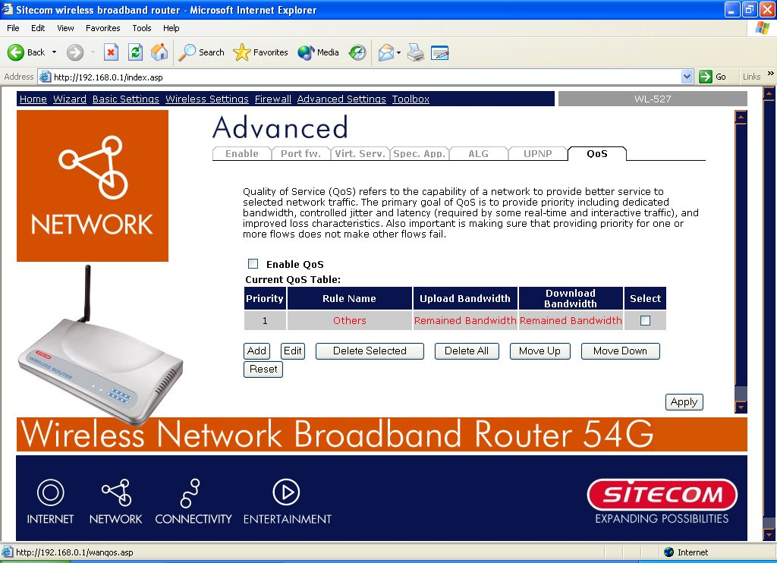
Parameters Description
Enable/Disable QoS You can check “Enable QoS” to enable QoS function for the WAN port. You also can uncheck “Enable QoS” to disable QoS function for the WAN port.
Add a QoS rule into the table Click “Add” then you will enter a form of the QoS rule. Click “Apply” after filling out the form and the rule will be added into the table.
Remove QoS rules from the table If you want to remove some QoS rules from the table, select the QoS rules you want to remove in the table and then click "Delete Selected". If you want remove all QoS rules from the table, just click "Delete All" button. Click "Reset" will clear your current selections.
Edit a QoS rule Select the rule you want to edit and click “Edit”, then you will enter the detail form of the QoS rule. Click “Apply” after editing the form and the rule will be saved.
Adjust QoS rule priority You can select the rule and click “Move Up” to make its priority higher. You also can select the rule and click “Move Down” to make its priority lower.

Edit QoS Rule:
You can assign packet classification criteria by its local IP range, remote IP range, traffic type, protocol, local port range and remote port range parameters. The parameters that you leave as blank will be ignored. The priority of this rule will be applied to packets that match classification criteria of this rule. You can limit bandwidth consumed by packets that match this rule or guarantee bandwidth required by packets that match this rule.
Parameters Description
Rule Name The name of this rule.
Bandwidth You can assign the download or upload bandwidth by the unit of Kbps (1024 bit per second). You can limit the maximum bandwidth consumed by this rule by selecting “Maximum”. You also can reserve enough bandwidth for this rule by selecting “Guarantee”.
Local IP Address Enter the local IP address range of the packets that this rule will apply to. If you assign 192.168.0.3 – 192.168.0.5, it means 3 IP addresses: 192.168.0.3, 192.168.0.4 and 192.168.0.5
Local Port Range Enter the local port range of the packets that this rule will apply to. You can assign a single port number here or assign a range of port numbers by assigning the first port number and the last port number of the range. The two numbers are separated by a dash “-“, for example “101-150” means from port number 100 to port number 150 – the range of 50 port numbers.
Remote IP Address Enter the remote IP address range of the packets that this rule will apply to. If you assign 192.168.2.3 – 192.168.2.5, it means 3 IP addresses: 192.168.2.3, 192.168.2.4 and 192.168.2.5
Remote Port Range Enter the remote port range of the packets that this rule will apply to. You can assign a single port number here or assign a range of port numbers by assigning the first port number and the last port number of the range. The two numbers are separated by a dash “-“, for example “101-150” means from port number 100 to port number 150 – the range of 50 port numbers.
Traffic Type Select the traffic type of the packets that this rule will apply to. We list some popular applications here to ease the configuration. You also can get the same result by using other parameters, for example source or destination port number, if you are familiar with the application protocol.
Protocol Select the protocol type of the packets that this rule will apply to.
Apply Apply and exit the form.
Reset Clear the content of this form.

Chapter 10 Tools
You can change the password required to log into the broadband router's system web-based management. By default, there is no password. So please assign a password to the Administrator as soon as possible, and store it in a safe place. Passwords can contain 0 to 12 alphanumeric characters, and are case sensitive.
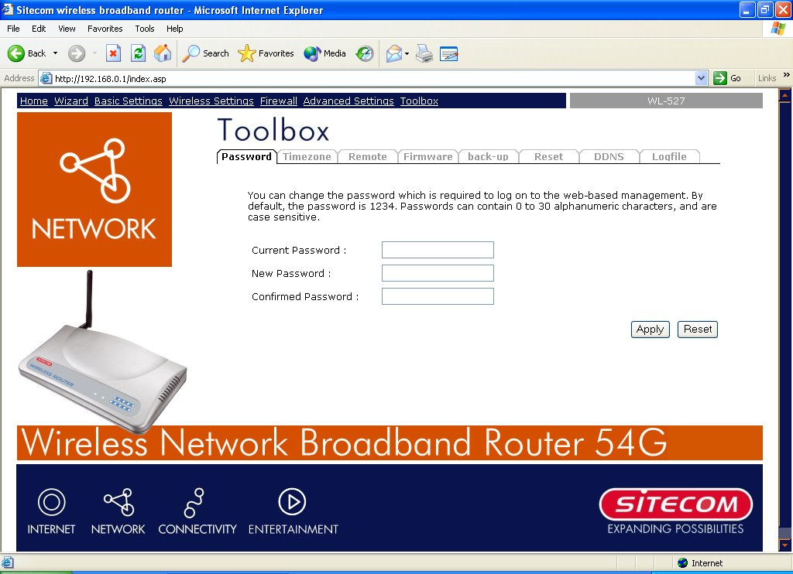
Parameters Description
Current Password Enter your current password for the remote management administrator to login to your Broadband router.
New Password Enter your new password
Confirmed Password Enter your new password again for verification purposes
Note: If you forget your password, you’ll have to reset the router to the factory default (password is admin) with the reset button (see router’s back panel).
Click <Apply> at the bottom of the screen to save the above configurations. You can now configure other advance sections or start using the router (with the advance settings in place)

10.1 Timezone
The Time Zone allows your router to reference or base its time on the settings configured here, which will affect functions such as Log entries and Firewall settings.
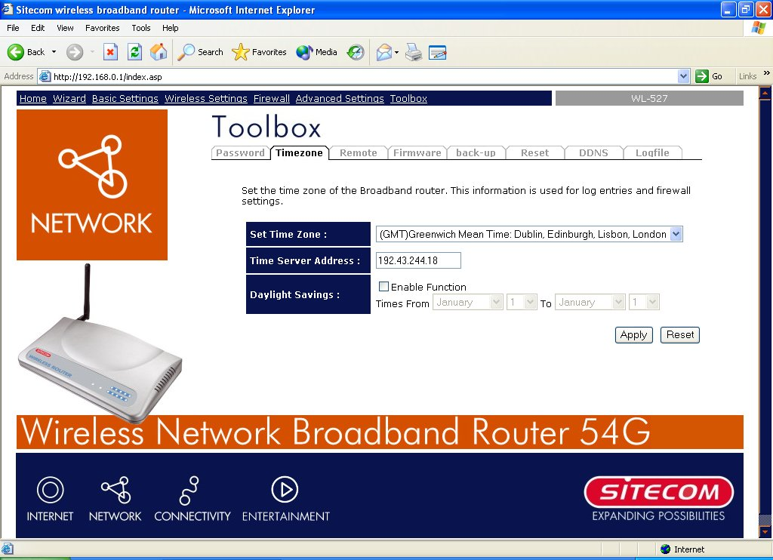
Parameter Description
Set Time Zone Select the time zone of the country you are currently in. The router will set its time based on your selection.
Time Server Address The router default the “Time Server Address” is “192.43.244.18”
Enable Daylight Savings The router can also take Daylight savings into account. If you wish to use this function, you must check/tick the enable box to enable your daylight saving configuration (below).
Start Daylight Savings Time Select the period in which you wish to start daylight Savings Time
End Daylight Savings Time Select the period in which you wish to end daylight Savings Time
Click <Apply> at the bottom of the screen to save the above configurations. You can now configure other advance sections or start using the router (with the advance settings in place)

10.2 Remote Management
The remote management function allows you to designate a host in the Internet the ability to configure the Broadband router from a remote site. Enter the designated host IP Address in the Host IP Address field.
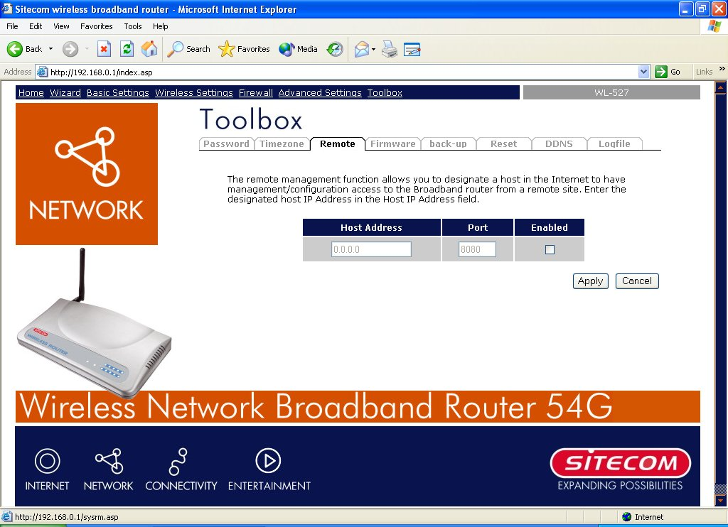
Parameters Description
Host Address This is the IP address of the host in the Internet that will have management/configuration access to the Broadband router from a remote site. This means if you are at home and your home IP address has been designated the Remote Management host IP address for this router (located in your company office), then you are able to configure this router from your home. If the Host Address is left 0.0.0.0 this means anyone can access the router’s web-based configuration from a remote location, providing they know the password.
Click the Enabled box to enable the Remote Management function.
Note: When you want to access the web-based management from a remote site, you must enter the router’s WAN IP address (e.g. 10.0.0.1) into your web-browser followed by port number 8080, e.g. 10.0.0.1:8080 (see below). You’ll also need to know the password set in the Password Setting screen in order to access the router’s web-based management.
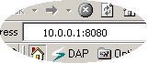
Port The port number of remote management web interface.
Enabled Select “Enabled” to enable the remote management function.
Click <Apply> at the bottom of the screen to save the above configurations. You can now configure other advance sections or start using the router (with the advance settings in place)

10.3 Firmware Upgrade
This page allows you to upgrade the router’s firmware.
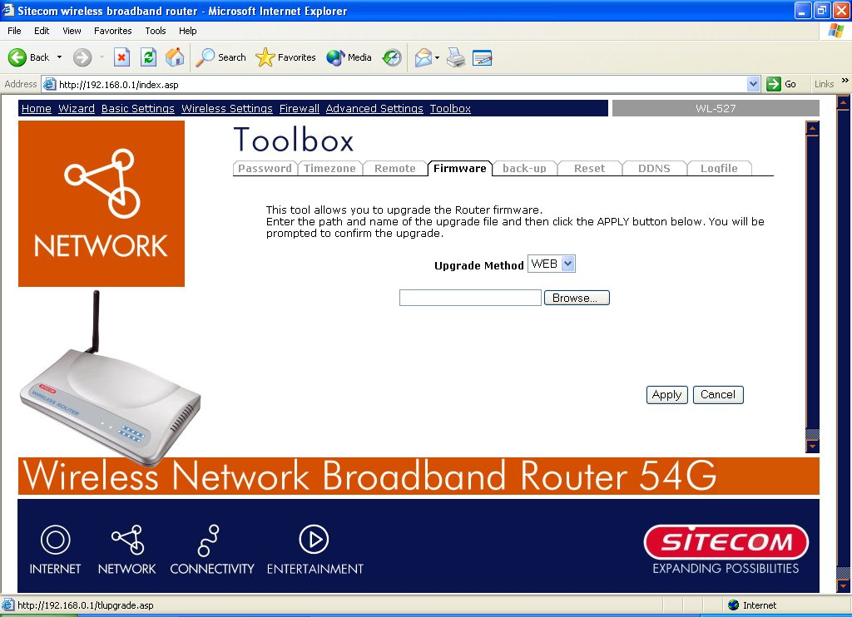
Parameters Description
Firmware Upgrade This tool allows you to upgrade the Broadband router’s system firmware. To upgrade the firmware of your Broadband router, you need to download the firmware file to your local hard disk, and enter that file name and path in the appropriate field on this page. You can also use the Browse button to find the firmware file on your PC.
Once you’ve selected the new firmware file, click <Apply> at the bottom of the screen to start the upgrade process. (You may have to wait a few minutes for the upgrade to complete). Once the upgrade is complete you can start using the router.

10.4 Back-up Settings
The Backup screen allows you to save (Backup) the router’s current configuration setting. Saving the configuration settings provides an added protection and convenience should problems occur with the router and you have to reset to factory default. When you save the configuration setting (Backup) you can re-load the saved configuration into the router through the Restore selection. If extreme problems occur you can use the Restore to Factory Defaults selection, this will set all configurations to its original default settings (e.g. when you first purchased the router).
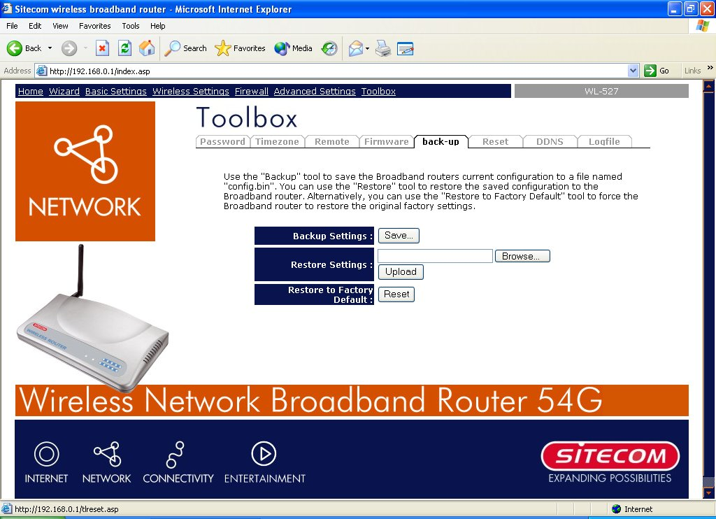
Parameters Description
Configuration Tools Use the "Backup" tool to save the Broadband router current configuration to a file named "config.bin" on your PC. You can then use the "Restore" tool to restore the saved configuration to the Broadband router. Alternatively, you can use the "Restore to Factory Defaults" tool to force the Broadband router to perform a power reset and restore the original factory settings.

10.5 Reset (restart) the router
You can reset the router’s system should any problem exist. The reset function essentially
Re-boots your router’s system.
Note: Your settings will NOT be changed by the system-reboot.

10.6 DDNS
DDNS allows you to map the static domain name to a dynamic IP address. You must get an account, password and your static domain name from the DDNS service providers. This router supports DynDNS, TZO and other common DDNS service providers.
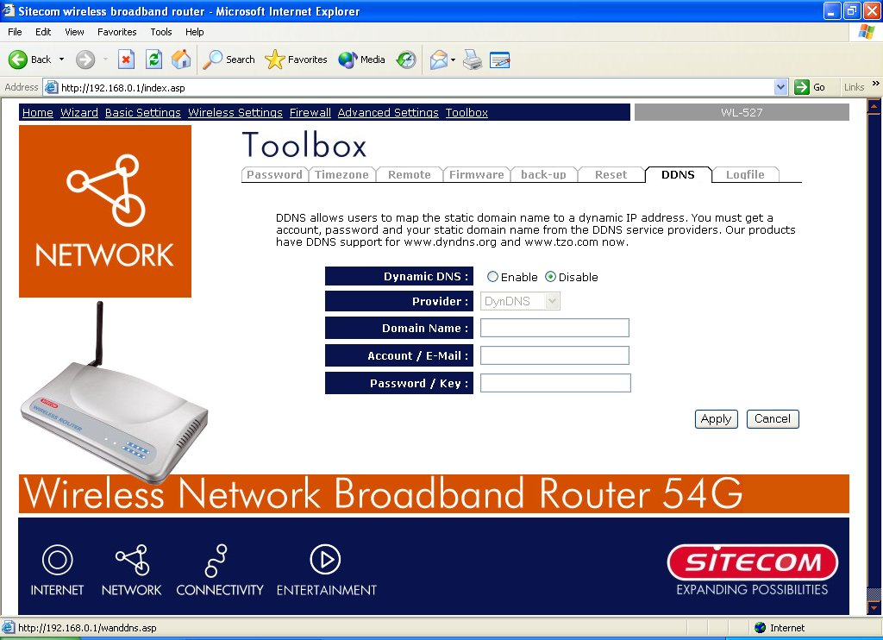
Parameters Description
Enable/Disable Enable/Disable the DDNS function of this router
Provider Select a DDNS service provider
Domain name Your static domain name that use DDNS
Account/E-mail The account that your DDNS service provider assigned to you
Password/Key The password you set for the DDNS service account above
Click <Apply> at the bottom of the screen to save the above configurations. You can now configure other advance sections or start using the router (with the advance settings in place)

Appendix A
How to Manually find your PC’s IP and MAC address
- In Window’s open the Command Prompt program
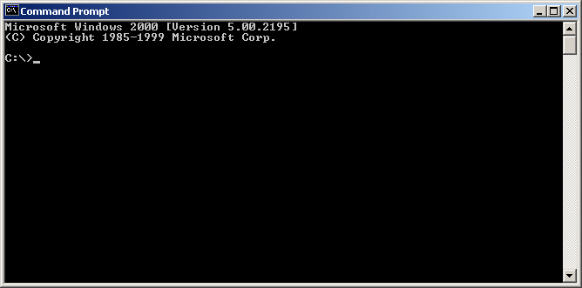
2) Type Ipconfig /all and <enter>
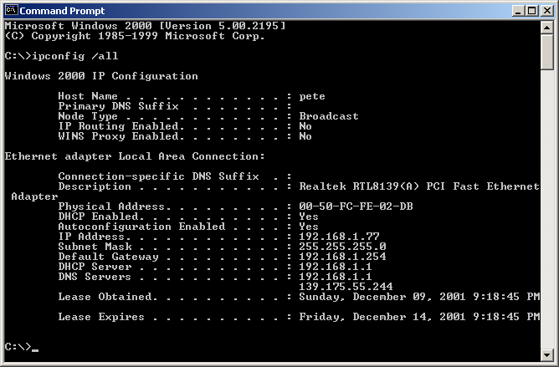
- Your PC’s IP address is the one entitled IP address (e.g. 192.168.1.77)
- The router’s IP address is the one entitled Default Gateway (e.g. 192.168.1.254)
- Your PC’s MAC Address is the one entitled Physical Address (e.g. 00-50-FC-FE-02-DB)

Glossary

Default Gateway (Router): Every non-router IP device needs to configure a default gateway’s IP address. When the device sends out an IP packet, if the destination is not on the same network, the device has to send the packet to its default gateway, which will then send it out towards the destination.
DHCP: Dynamic Host Configuration Protocol. This protocol automatically gives every computer on your home network an IP address.
DNS Server IP Address: DNS stands for Domain Name System, which allows Internet servers to have a domain name (such as www.Broadbandrouter.com) and one or more IP addresses (such as 192.34.45.8). A DNS server keeps a database of Internet servers and their respective domain names and IP addresses, so that when a domain name is requested (as in typing "Broadbandrouter.com" into your Internet browser), the user is sent to the proper IP address. The DNS server IP address used by the computers on your home network is the location of the DNS server your ISP has assigned to you.
DSL Modem: DSL stands for Digital Subscriber Line. A DSL modem uses your existing phone lines to transmit data at high speeds.
Ethernet: A standard for computer networks. Ethernet networks are connected by special cables and hubs, and move data around at up to 10/100 million bits per second (Mbps).
Idle Timeout: Idle Timeout is designed so that after there is no traffic to the Internet for a pre-configured amount of time, the connection will automatically be disconnected.
IP Address and Network (Subnet) Mask: IP stands for Internet Protocol. An IP address consists of a series of four numbers separated by periods, that identifies a single, unique Internet computer host in an IP network. Example: 192.168.0.1. It consists of 2 portions: the IP network address, and the host identifier.

The IP address is a 32-bit binary pattern, which can be represented as four cascaded decimal numbers separated by “.”: aaa.aaa.aaa.aaa, where each “aaa” can be anything from 000 to 255, or as four cascaded binary numbers separated by “.”: bbbbbbbb.bbbbbbbb.bbbbbbbb.bbbbbbbb, where each “b” can either be 0 or 1.
A network mask is also a 32-bit binary pattern, and consists of consecutive leading
1’s followed by consecutive trailing 0’s, such as
11111111.11111111.11111111.00000000. Therefore sometimes a network mask can also be described simply as “x” number of leading 1’s.
When both are represented side by side in their binary forms, all bits in the IP address that correspond to 1’s in the network mask become part of the IP network address, and the remaining bits correspond to the host ID.

For example, if the IP address for a device is, in its binary form,
11011001.10110000.10010000.00000111, and if its network mask is,
11111111.11111111.11110000.00000000
It means the device’s network address is
11011001.10110000.10010000.00000000, and its host ID is,
00000000.00000000.00000000.00000111. This is a convenient and efficient method for routers to route IP packets to their destination.
ISP Gateway Address: (see ISP for definition). The ISP Gateway Address is an IP address for the Internet router located at the ISP's office.
ISP: Internet Service Provider. An ISP is a business that provides connectivity to the Internet for individuals and other businesses or organizations.
LAN: Local Area Network. A LAN is a group of computers and devices connected together in a relatively small area (such as a house or an office). Your home network is considered a LAN.
MAC Address: MAC stands for Media Access Control. A MAC address is the hardware address of a device connected to a network. The MAC address is a unique identifier for a device with an Ethernet interface. It is comprised of two parts: 3 bytes of data that corresponds to the Manufacturer ID (unique for each manufacturer), plus 3 bytes that are often used as the product’s serial number.
NAT: Network Address Translation. This process allows all of the computers on your home network to use one IP address. Using the broadband router’s NAT capability, you can access the Internet from any computer on your home network without having to purchase more IP addresses from your ISP.
Port: Network Clients (LAN PC) uses port numbers to distinguish one network application/protocol over another. Below is a list of common applications and protocol/port numbers:
Application | Protocol | Port Number
Telnet | TCP | 23
FTP | TCP | 21
SMTP | TCP | 25
POP3 | TCP | 110
H.323 | TCP | 1720
SNMP | UCP | 161
SNMP Trap | UDP | 162
HTTP | TCP | 80
PPTP | TCP | 1723
PC Anywhere | TCP | 5631
PC Anywhere | UDP | 5632
PPPoE: Point-to-Point Protocol over Ethernet. Point-to-Point Protocol is a secure data transmission method originally created for dial-up connections; PPPoE is for Ethernet connections. PPPoE relies on two widely accepted standards, Ethernet and the Point-to-Point Protocol. It is a communications protocol for transmitting information over Ethernet between different manufacturers
Protocol: A protocol is a set of rules for interaction agreed upon between multiple parties so that when they interface with each other based on such a protocol, the interpretation of their behavior is well defined and can be made objectively, without confusion or misunderstanding.
Router: A router is an intelligent network device that forwards packets between different networks based on network layer address information such as IP addresses.
Subnet Mask: A subnet mask, which may be a part of the TCP/IP information provided by your ISP, is a set of four numbers (e.g. 255.255.255.0) configured like an IP address. It is used to create IP address numbers used only within a particular network (as opposed to valid IP address numbers recognized by the Internet, which must be assigned by InterNIC).
TCP/IP, UDP: Transmission Control Protocol/Internet Protocol (TCP/IP) and Unreliable Datagram Protocol (UDP). TCP/IP is the standard protocol for data transmission over the Internet. Both TCP and UDP are transport layer protocol. TCP performs proper error detection and error recovery, and thus is reliable. UDP on the other hand is not reliable. They both run on top of the IP (Internet Protocol), a network layer protocol.
WAN: Wide Area Network. A network that connects computers located in geographically separate areas (e.g. different buildings, cities, countries). The Internet is a wide area network.
Web-based management Graphical User Interface (GUI): Many devices support a graphical user interface that is based on the web browser. This means the user can use the familiar Netscape or Microsoft Internet Explorer to Control/configure or monitor the device being managed.

