
ADSL Homestation DC-214v2/216v2

full manual

1. Introduction 4
1.2 Package Contents 4
1.3 The DC-214/216 ADSL Homestation Features 5
1.4 Physical details 6
The Front LEDs 6
The Rear Ports 6
1.5 Cabling 7
2. Installation 8
2.1 Installing the USB Driver 8
Windows XP 8
Windows 2000 11
Windows Me 14
Windows 98 17
3. Configuring the Network Properties 23
Windows 98/ME 23
Windows 2000/XP 23
Windows 98/ME/2000/XP 23
4. Configuration Utility 25
5. Advanced Configuration. 29
5.1 Default settings 29
5.2 Password 29
5.3 Information from ISP 30
5.4 Configuring with Web Browser 32
5.5 Status 33
5.5.1 Homepage 33
5.5.2 Status – ADSL Status 34
5.5.3 WAN Status 35
5.5.4 ATM Status 36
5.5.5 TCP Status 37
5.6 Configuration 38
5.6.1 WAN Configuration 38
5.6.2 LAN Configuration 41
5.6.3 NAT Configuration 43
5.6.4 Save Settings 45
5.7 Advanced 46
5.7.1 Virtual Server Configuration 46
5.7.2 Bridge Filtering Configuration 48
5.7.3 DNS Configuration 49
5.7.4 ADSL Configuration 50
5.7.5 Route Table 51
5.7.6 Learned ( Bridge ) MAC Table 53
5.7.7 RIP Configuration 54
5.7.8 Miscellaneous Configuration 56
5.8 Admin 58
5.8.1 Password Configuration 58
5.8.2 Reset to Factory Default 59
5.8.3 Diagnostic Test 60
5.8.4 System Log 63
5.8.5 Network Code Image Update 64
5.8.6 Firmware Update 65
5.8.7 Bootcode Update 65
6. Trouble shooting 66
6.1 Problems Starting Up the ADSL Router 66
6.2 Problems with the WAN Interface 66
6.3 Problems with the LAN Interface 66
6.4 Problems Connecting to a Remote Node or ISP 66
7. Specifications 67

1. Introduction
The DC-214/216 ADSL Homestation provides a high-speed Ethernet port and an USB port for high-speed Internet browsing. It can support downstream transmission rates of up to 8Mbps and upstream transmission rates of up to 1024Kbps. It is compliant with Multi-Mode standard (ANSI T1.413, Issue 2; G.dmt (G.992.1); G.lite (G992.2); G.hs (G994.1)).
It is the perfect solution to connect a small group of PCs to a high-speed broadband Internet connection. Multi-users can have high-speed Internet access simultaneously.
This product also serves as an Internet firewall, protecting your network from being accessed by outside users. Not only provide the natural firewall function (Network Address Translation, NAT), it also provides rich firewall features to secure user’s network. All incoming data packets are monitored and filtered. Besides, it can also be configured to block internal users from accessing to the Internet.
The product provides two levels of security support. First, it masks LAN users’ IP addresses which are invisible to outside users on the Internet, making it much more difficult for a hacker to target a machine on your network. Secondly, it can block and redirect certain ports to limit the services that outside users can access. For example, to ensure that games and other Internet applications will run properly, users can open some specific ports for outside users to access internal services in network.
Integrated DHCP services, client and server, allow multiple users to get their IP addresses automatically on boot up from the product. Simply set local machines as a DHCP client to accept a dynamically assigned IP address from DHCP server and reboot. Each time local machine is powered up; the router will recognize it and assign an IP address and instantly connect it to the LAN.
For advanced users, the Virtual Service function allows the product to provide limited visibility to local machines with specific services for outside users. An ISP provided IP address can be set to the product and then specific services can be rerouted to specific computers on the local network. For instance, a dedicated web server can be connected to the Internet via the product and then incoming requests for HTML that are received by the product can be rerouted to the dedicated local web server, even though the server now has a different IP address. In this example, the product is on the Internet and vulnerable to attacks, but the server is protected.
Virtual Server can also be used to re-task services to multiple servers. For instance, the product can be set to allow separated FTP, Web, and Multiplayer game servers to share the same Internet-visible IP address while still protecting the servers and LAN users from hackers.

1.2 Package Contents
- DC-214/216 ADSL Homestation
- One CD-ROM containing the driver and online manual
- One Quick Start Guide
- One RJ-11 ADSL/telephone cable
- One CAT-5 crossover LAN cable
- One USB cable
- One power adapter

1.3 The DC-214/216 ADSL Homestation Features
The DC-214/216 ADSL Homestation provides the following features:
ADSL Multi-Mode Standard: Supports downstream transmission rates of up to 8Mbps and upstream transmission rates of up to 1024Kbps. It is compliant with Multi-Mode standard (ANSI T1.413, Issue 2; G.dmt (G.992.1); G.lite (G992.2); G.hs (G994.1)).
Multi-Protocol to Establish A Connection: Supports PPPoA (RFC 2364 - PPP over ATM Adaptation Layer 5), RFC 1483 encapsulation over ATM (bridged or routed), PPP over Ethernet (RFC 2516) and IPoA (RFC1577) to establish a connection with ISP. The product also supports VC-based and LLC-based multiplexing.
Network Address Translation (NAT): Allows multi-users to access outside resource such as Internet simultaneously with one IP address/one Internet access account. Besides, many application layer gateway (ALG) are supported such as web browser, ICQ, FTP, Telnet, E-mail, News, Ping and others.
Domain Name System (DNS) relay: Provides an easy way to map the domain name (a friendly name for user such as www.yahoo.com) and IP address. When local machine sets its DNS server with this router’s IP address. Then every DNS conversion request packet from the PC to this router will be forwarded to the real DNS in outside network. After the router gets the reply, then forwards it back to the PC.
PPP over Ethernet (PPPoE): Provides embedded PPPoE client function to establish a connection. Users can get greater access speed without changing the operation concept, sharing the same ISP account and paying for one access account. No PPPoE client software is required for local computer. The Automatic Reconnect and Disconnect Timeout (Idle Timer) functions are provided, too.
Virtual Server: User can specify some services to be visible from outside users. The router can detect incoming service request and forward it to the specific local computer to handle it. For example, user can assign a PC in LAN acting as WEB server inside and expose it to the outside network. Outside user can browse inside web server directly while it is protected by NAT. A DMZ host setting is also provided to a local computer exposed to the outside network, Internet.
Bridge Filtering: Filters the packet based on MAC address. It will increase the performance in LAN and WAN, also provide a higher-level security control.
Dynamic Host Control Protocol (DHCP) client and server: In the WAN site, the DHCP client can get an IP address from the Internet Server Provider (ISP) automatically. In the LAN site, the DHCP server can allocate multiple clients IP addresses and distribute them including IP address, subnet mask as well as DNS IP address to local computers. It provides an easy way to manage the local IP network.
Web based GUI: Supports user-friendly web based GUI for configuration and management.

1.4 Physical details

The Front LEDs
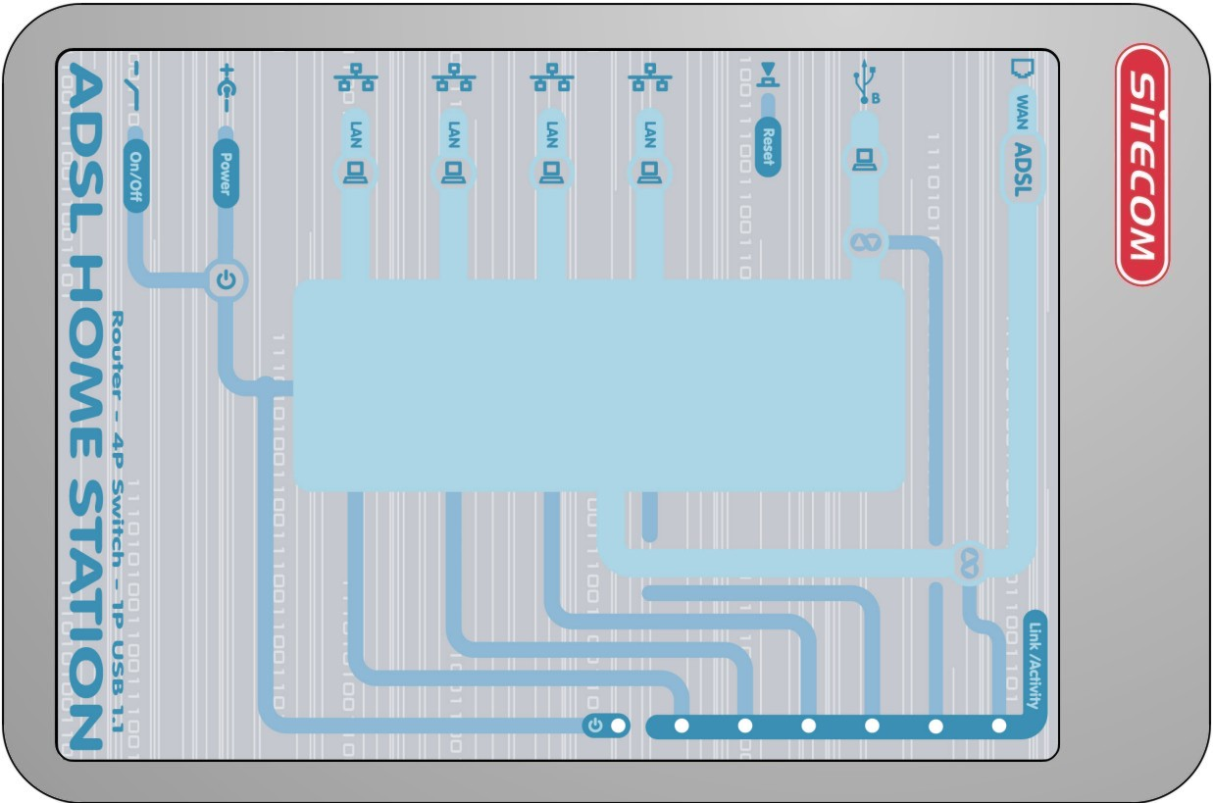

Power | USB | LAN | ADSL
When flashing, it indicates that the device is turned on and working properly. | When this LED is lit, it indicates that the USB port is connected to the PC and working properly. When flashing data is received/send | When lit, it indicates that the LAN port is connected to the PC and working properly. When flashing data is received/send | When lit, it indicates the ADSL port is connected with the DSLAM and working properly. When flashing data is received/send.

The Rear Ports
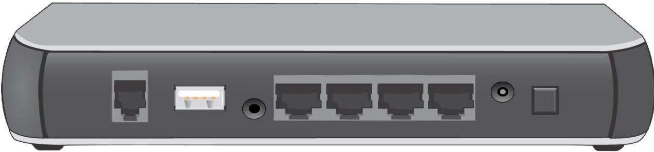
LINE  (RJ-11 connector) | USB  (USB connector) | Reset | Ethernet Port  (RJ-45 connector) | Power  (jack) | On/Off
Connect the supplied RJ-11 cable to this port and the ADSL wallplug | Connect the supplied USB cable to this port when connecting to the PC. | Press to restore to the factory default settings. | Connect the supplied crossover cable to this port when connecting to a NIC (Network Interface card) in a PC.  Connect an UTP Ethernet cable to this port when connecting to a LAN such as an office or home network. | Connect the supplied power adapter to this jack. | Turn the modem/router on or off

1.5 Cabling
Through Ethernet Port
Connect the LAN cables: Use standard LAN cables to connect the PCs to the LAN ports (switch) on the homestation.
Make sure that all connected devices are turned on. Please, check that the PWR, LAN LNK and ADSL SYN LEDs are lit. If they are not, verify that you are using the proper cables.
If the cables are connected and the LEDs are lit normally, please go to section “3. Configuring the Network Properties” to modify the network settings.
Through USB Port
The product can be used as a Network Adapter on your PC. That means you do not have to install a network adapter first on your PC before connecting the DC-214/216 ADSL Homestation. Just connect the supplied USB cable to the USB port of the ADSL Homestation and connect the other end to the PC.
Make sure that all connected devices are turned on. Please, check that the PWR, and ADSL SYN LEDs are lit. If they are not, verify that you are using the proper cables.
If the cables are connected and the LEDs are lit normally, please go to section “2. Installing the USB Driver” below to setup this device.
Connect ADSL/power
Connect your ADSL cable to the LINE port on the homestation.
Connect the power adapter to the homestation. Only use the adapter that is delivered with your homestation. Connect the power cord to power inlet and turn the power switch on.
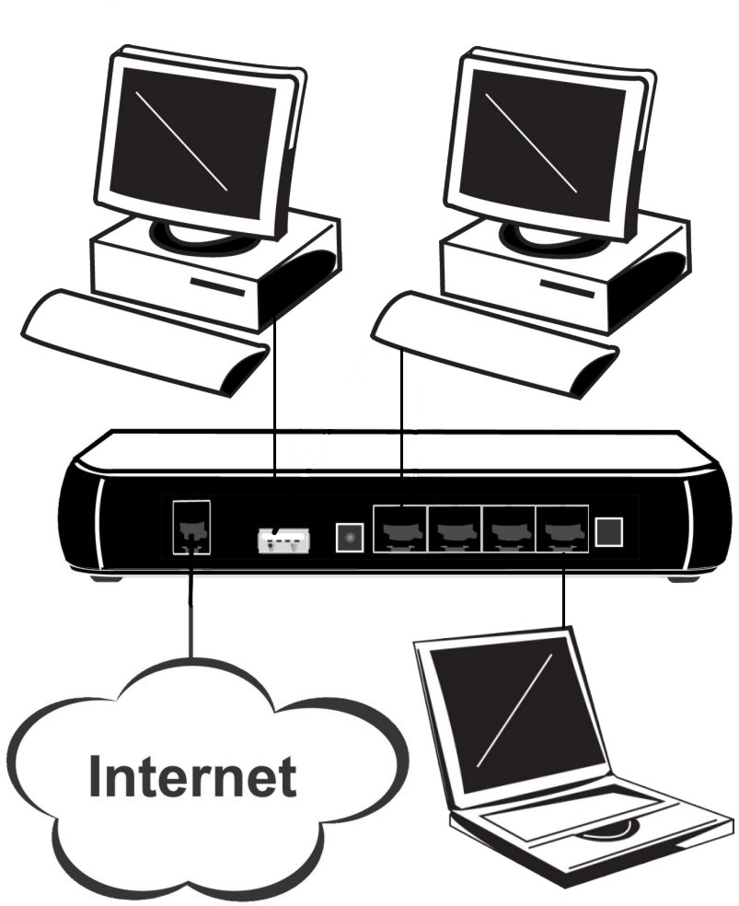

2. Installation

2.1 Installing the USB Driver
If you connect the ADSL Homestation to the USB port, for the first time the USB cable is connected to the PC, Windows will automatically detect the device. Follow the steps to install the USB driver.

Windows XP
- Select “Install from a list or specific location” and click “Next >”.
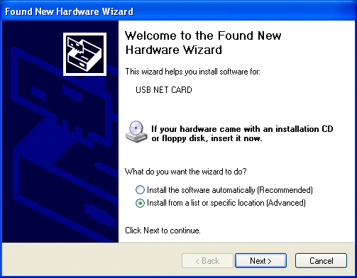
- Insert the installation CD into the CD-ROM drive. Check “Include this location in the search” and click “browse”. Browse to the ‘driver’ folder on the CD-Rom. Click “Next >”.
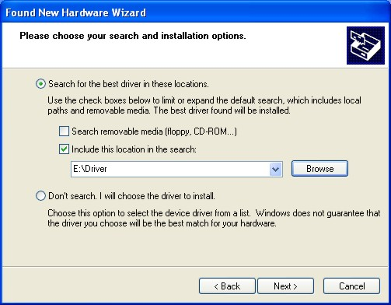

- Click “Continue Anyway” to pass the windows logo test.
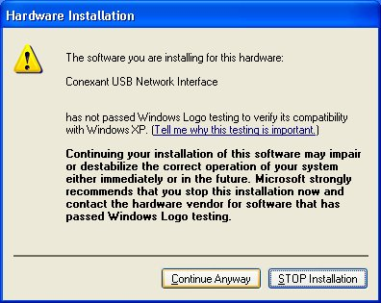
- Click “Continue Anyway” to pass the windows logo test.
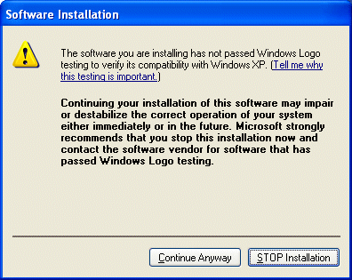
- Click “Finish”.
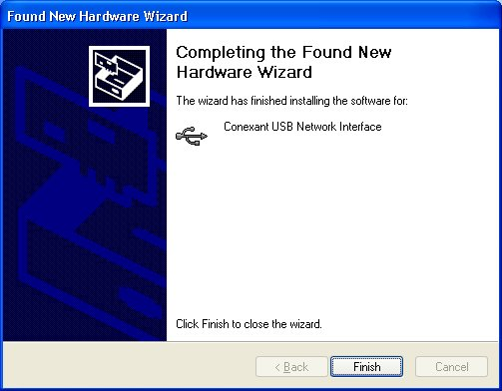
- After a few moments, Windows will detect a new device, USB ADSL Adapter. Select “Install from a list or specific location”. Click “Next >”.
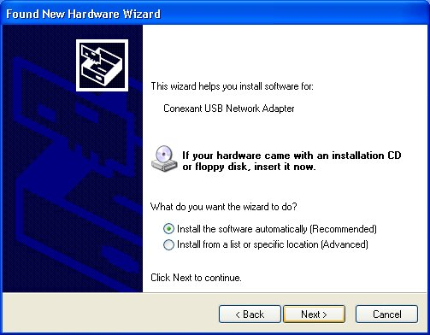
- Check “Include this location in the search” and click “browse”. Browse to the ‘driver’ folder on the CD-Rom. Click “Next >”.
- Click “Continue Anyway” to pass the windows logo test.
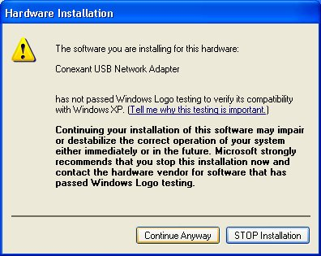
- Click “Finish” to end installation.
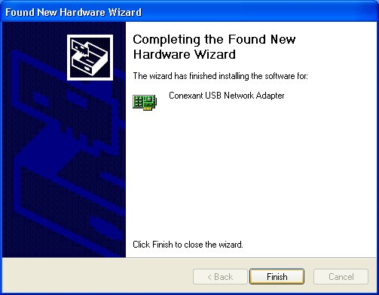
- After installing the driver, follow the section “3. Configuring the Network Properties” below to modify the network settings on your PC.

Windows 2000
- Click “Next >”.
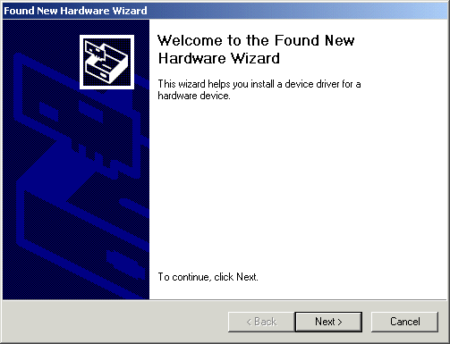
- Insert the installation CD into the CD-ROM drive. Select “Search for a suitable driver for my device”. Click “Next>”.
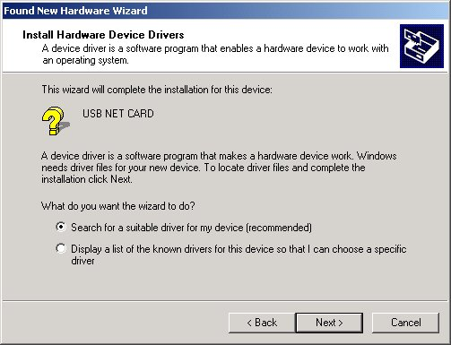
- Check “Specify a location”. Click “Next >”.
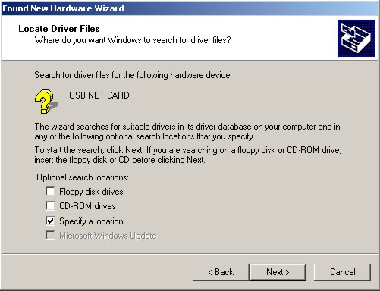
- Click “browse”. Browse to the ‘driver’ folder on the CD-Rom. Click “Next >”.
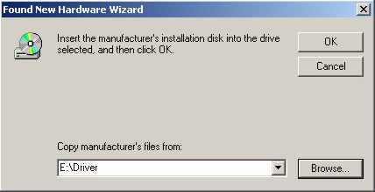

- Click “Next >” .
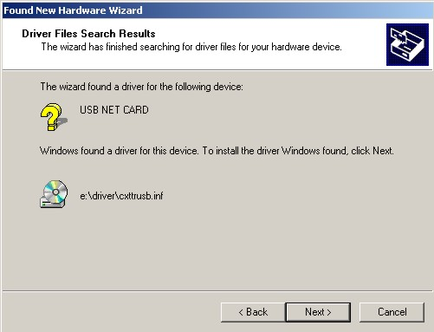
- Click “Yes” to pass the digital signature.
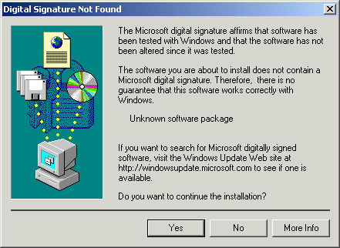
- Press “Finish”.
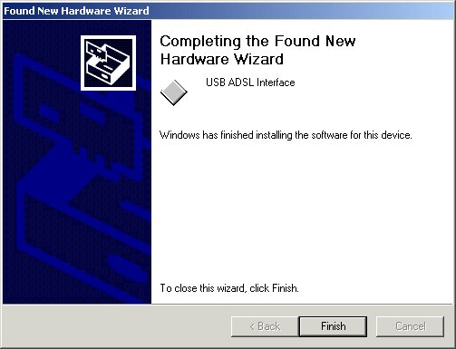
- Click “Yes” to pass the digital signature.
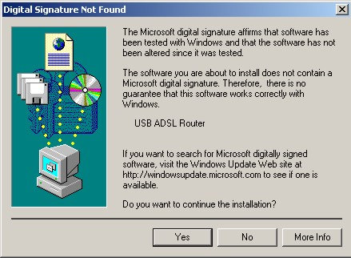
- After installing the driver, follow the section “3. Configuring the Network Properties” below to modify the network settings on your PC.

Windows Me
- Select “Specify the location of the driver”. Click “Next >”.
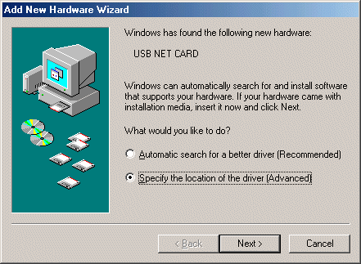
- Insert the installation CD into the CD-ROM drive. Select “Specify a location”. and click “browse”. Browse to the ‘driver’ folder on the CD-Rom. Click “Next >”.
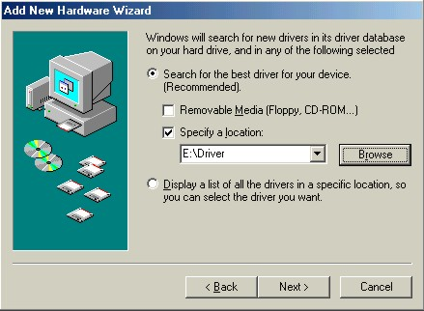
- Click “Next >“.
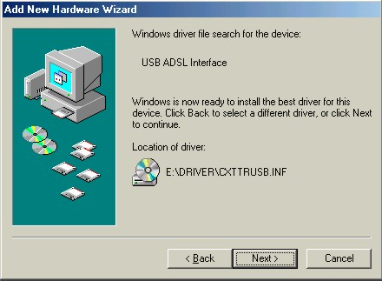
- Windows will start copying files to your system. Click “Finish”.
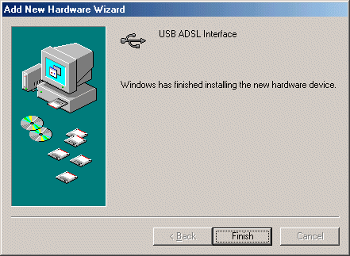

- Select “Specify the location of the driver”. Click “Next >”.
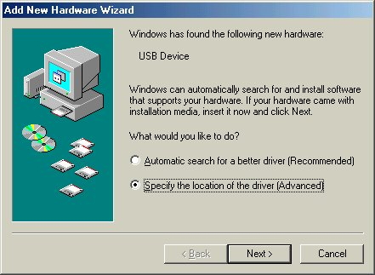
- Insert the installation CD into the CD-ROM drive. Select “Specify a location”. and click “browse”. Browse to the ‘driver’ folder on the CD-Rom. Click “Next >”.
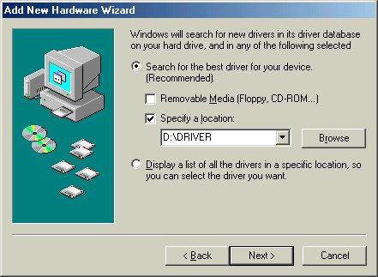
- Click “Next >“.
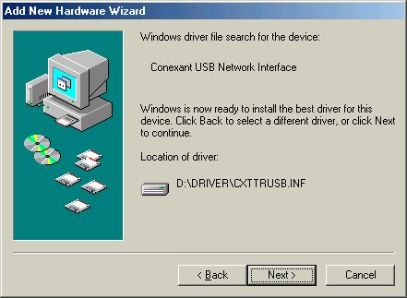
- Windows will start copying files to your system. Click “Finish”.
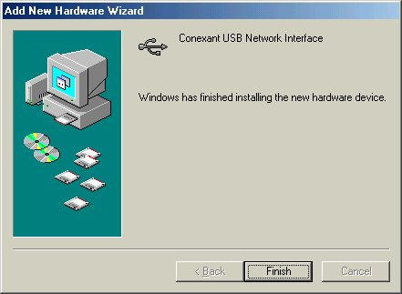
- Click “Yes” to restart your PC.
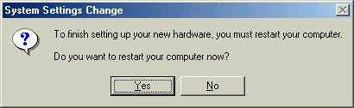
- After installing the driver, follow the section “3. Configuring the Network Properties” below to modify the network settings on your PC.

Windows 98
- Click “Next >”.
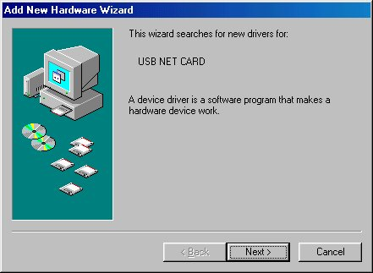

- Select “Search for the best driver for your device [Recommended]”. Click “Next >”.
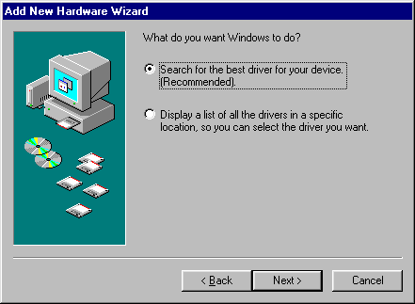
- Insert the installation CD into the CD-ROM drive. Select “Specify a location”. and click “browse”. Browse to the ‘driver’ folder on the CD-Rom. Click “Next >”.
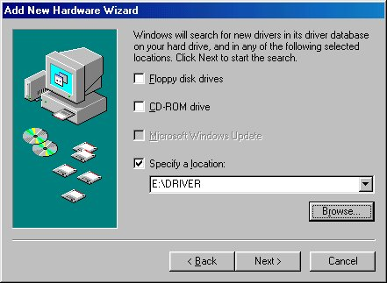
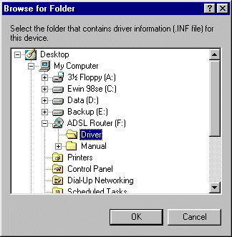
- Click “Next >“.
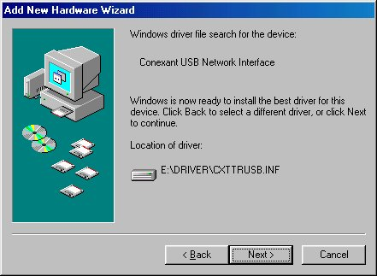
- Windows will start copying files to your system. Then, click “Finish”.
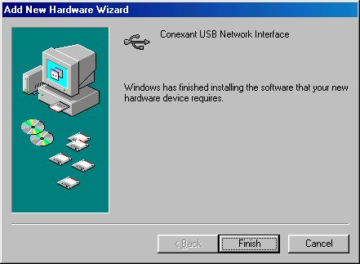
- Click “Next >“.
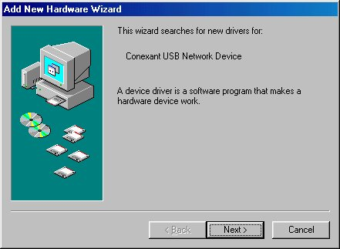

- Select “Search for the best driver for your device [Recommended]”. Click “Next >”.
- Insert the installation CD into the CD-ROM drive. Select “Specify a location”. and click “browse”. Browse to the ‘driver’ folder on the CD-Rom. Click “Next >”.
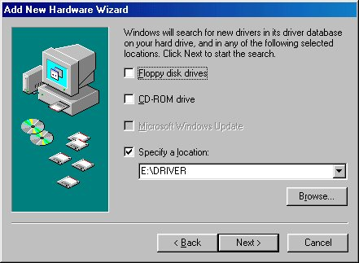
- Click “Next >“.
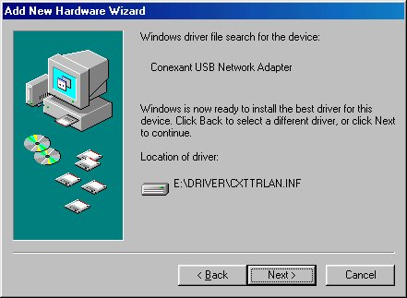
- You will see the following screen prompting for the path of the Windows source files. Please specify a location of the original windows CD-Rom. Click “OK”.
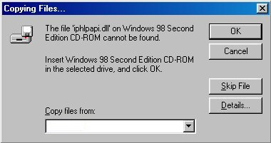
- Windows will start copying files to your system. Then, click “Finish”.
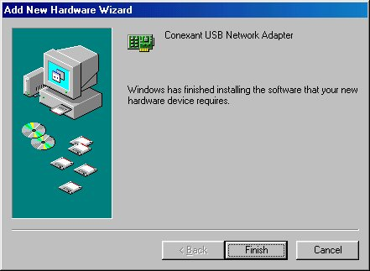

- Click “Yes” to restart your PC.
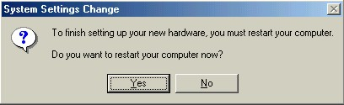
- After installing the driver, follow the section “3. Configuring the Network Properties” below to modify the network settings on your PC.

3. Configuring the Network Properties

Windows 98/ME
Right click the icon My Network Places on your desktop and then choose Properties. A window opens, like the one below:

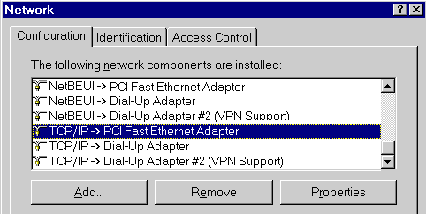

Windows 2000/XP
Right click the icon My Network Places on your desktop and then choose Properties. A window opens, like the one below:

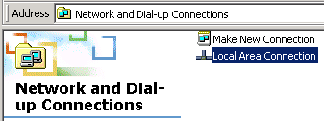

Right click the Local Area Connection of the correct network card, and then choose Properties.

Windows 98/ME/2000/XP
Select the line “ Internet Protocol” (2000/XP) or "TCP/IP -> network card" (98/ME), as illustrated below.
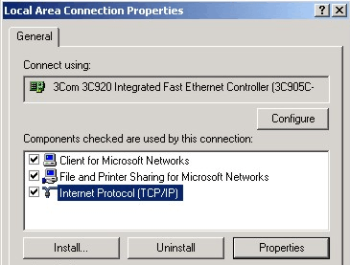

Click on the button Properties to get a similar screen as the one that is illustrated below.

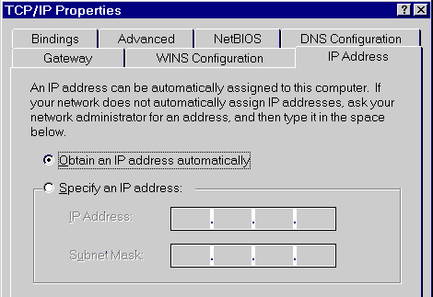

Ensure "Obtain an IP address automatically" has been selected, as is illustrated above. The DHCP server in the broadband router will assign an IP address to the PC.

Restart your PC, even if you have not made any changes.
NOTE: If the list that appears on screen does not include a line, such as the one that has been selected above ("TCP/IP -> network card"), follow the steps below:
- Click on the button "Add"
- Double-click on "Protocol"
- Select "Microsoft" and then "TCP/IP"
- Click on "OK"
- Wait a few seconds, so that TCP/IP can be added. Then, click "OK" to leave the network properties screen. Restart your PC.

4. Configuration Utility
The configuration utility is a very easy to use windows application to configure your router. It should only be installed on just 1 PC connected to the your DC-213/214/215/216.
Browse to the Utility folder on the CD-Rom and click the set-up. The set-up wizard will start, click ‘Next’.
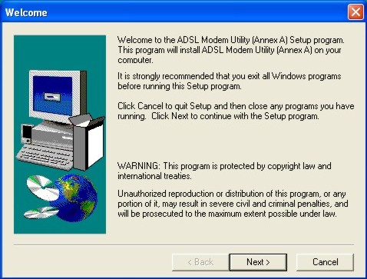
You can change the default installation folder, or Click ‘Next’
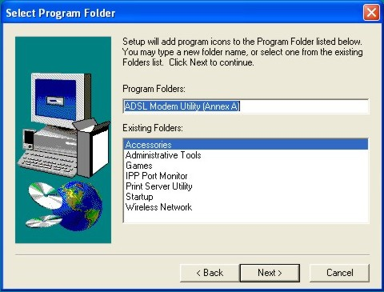

The set-up gathered enough information. Click ‘Next’.
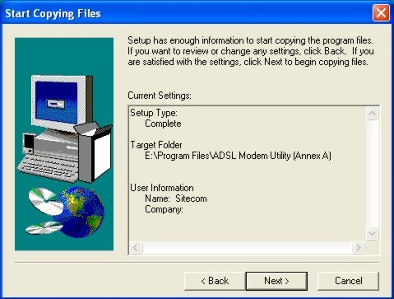
Click ‘Finish’ to restart the PC
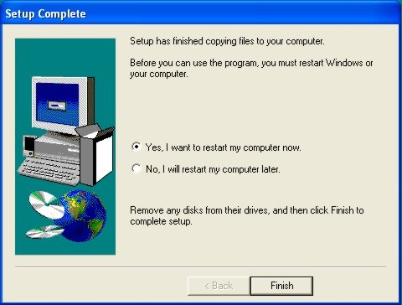
After the reboot, please start the utility via start/programs/ADSL homestation Utility
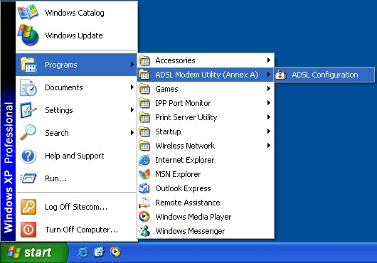
First, select the type of ADSL router your using (please check product number underneath the device).
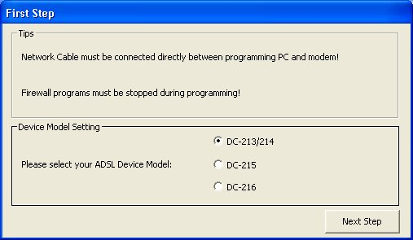
In the Utility select your country. When your country is not listed select ‘manual configuration’. In that case you need additional information from your provider about protocols, encapsulation, and VPI/VCI settings.
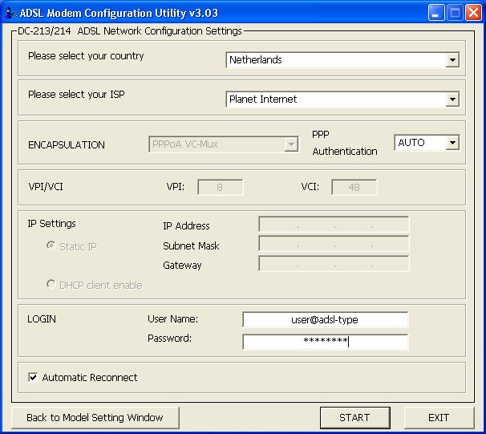
Choose your ISP. Besides a username or password, no additional settings like Encapsulation and VPI/VCI settings are required. The utility will set-up your DC-213/215 or DC-214/216 automatically for the chosen ISP.
If you want the homestation to maintain the connection at all time, enable ‘Automatic Reconnect’.
Click ‘START’ to start the automatic configuration procedure.
The Utility will copy all necessary settings to the DC-213/215 or DC-214/216. Do not interrupt this process, which could take up to 2 minutes. A status screen in the Utility window will indicate the process.
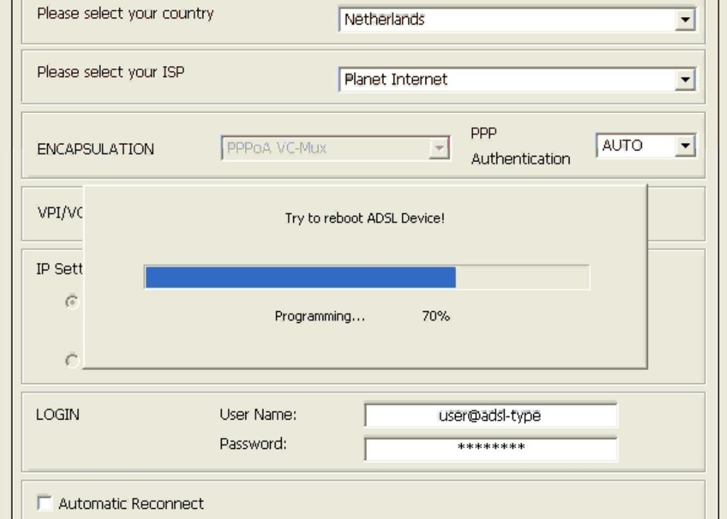
When the configuration is completed, the status screen will disappear. After this, click ‘Exit’ to quit the Utility.

5. Advanced Configuration.

5.1 Default settings
- password
 | User Name | Password
Administrator Level | admin | admin
- Device IP LAN site
IP Address : 10.0.0.1
Subnet Mask : 255.255.255.0
- ISP setting in WAN site
Virtual Circuit 0: 1483 Routed IP LLC
Virtual Circuit 1 ~ 7 : 1483 Bridged IP LLC
- DHCP server
DHCP server is enabled.
IP address pool from IP Address : 10.0.0.100 to IP Address : 10.0.0.199

5.2 Password
If you want to configure the device, type admin in the username field and admin in the password field. Then, click “OK” to log in. You can modify this password for security and management purpose.
 | If you ever forget the password to log in, you should contact the dealer where you bought this product.

5.3 Information from ISP
Before you start configuring this device, you have to check with your ISP what kind of service is provided, including the following:
- PPPoE VC-Mux
- PPPoE LLC
- PPPoE None
- PPPoA VC-Mux
- PPPoA LLC
- 1483 Bridged IP VC-Mux
- 1483 Bridged IP LLC
- 1483 Routed IP VC-Mux
- 1483 Routed IP LLC
- Classical IP over ATM
- Native ATM

Gather the information as illustrated in the following table and keep it for reference.
PPPoE VC-Mux | VPI/VCI, Service Name, Username, Password, and Domain Name System (DNS) IP address (it can be automatically assigned from ISP or be set fixed).
PPPoE LLC | VPI/VCI, Service Name, Username, Password, and Domain Name System (DNS) IP address (it can be automatically assigned from ISP or be set fixed).
PPPoE None | VPI/VCI, Service Name, Username, Password, and Domain Name System (DNS) IP address (it can be automatically assigned from ISP or be set fixed).
PPPoA VC-Mux | VPI/VCI, Username, Password, and Domain Name System (DNS) IP address (it can be automatically assigned from ISP or be set fixed).
PPPoA LLC | VPI/VCI, Username, Password, and Domain Name System (DNS) IP address (it can be automatically assigned from ISP or be set fixed).
1483 Bridged IP LLC | VPI/VCI
1483 Bridged IP VC-Mux | VPI/VCI
1483 Routed IP LLC | VPI/VCI, IP address, Subnet mask, Gateway address, and Domain Name System (DNS) IP address (it is fixed IP address).
1483 Routed IP VC-Mux | VPI/VCI, IP address, Subnet mask, Gateway address, and Domain Name System (DNS) IP address (it is fixed IP address).
Classical IP over ATM | VPI/VCI, IP address, Subnet mask, Gateway address, and Domain Name System (DNS) IP address (it is fixed IP address).

5.4 Configuring with Web Browser
The ADSL Homestation can be configured with your Web browser.
Open the web browser, enter the IP address of the ADSL Router, which default is 10.0.0.1, click enter.
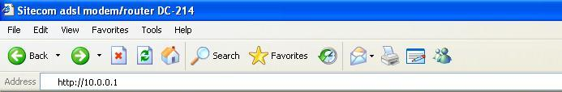
You’ll see the log-in windows. Type your username and password.
The default User Name is admin (or user if you log-on in user level), the default password is admin. Click ‘OK’
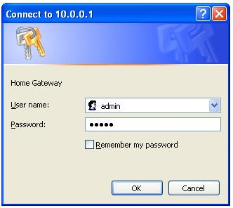

5.5 Status

5.5.1 Homepage
This screen contains information of the software version of your device and some settings, such as IP Address, Subnet Mask, and MAC Address of the WAN and LAN connections.
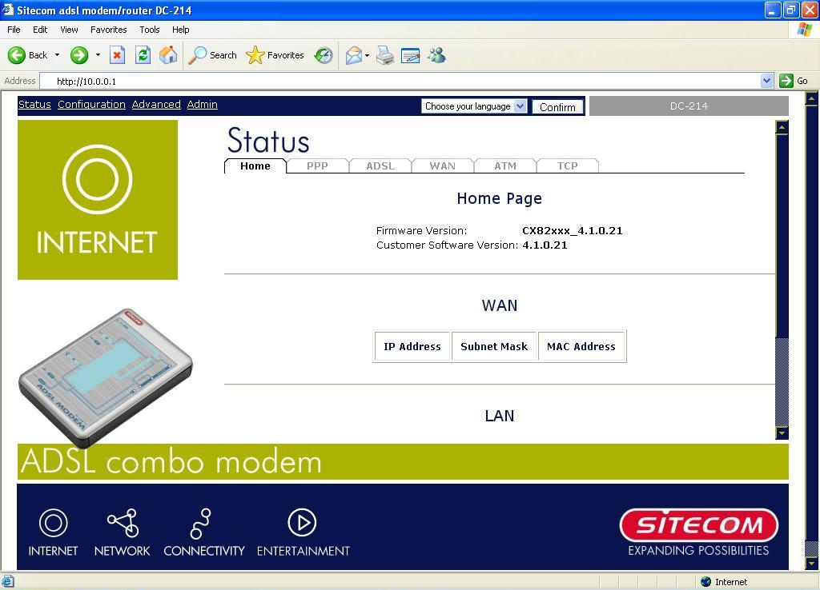
Language: Here you can change the language of the user interface.
Firmware Version: This field displays the firmware version number.
Customer Software Version: This field displays the customer’s own firmware version
number and it is based on revision.txt.
WAN: These fields display the IP address, Subnet Mask and MAC address for the WAN
(ADSL) interface.
LAN: These fields display the IP address, Subnet Mask and MAC address for the LAN
interface.
Total Number of LAN Interfaces: This field displays the total number of available
interfaces for the LAN interface.
Number of Ethernet Devices Connected to the DHCP Server: These fields display the
DHCP client table with the assigned IP addresses and MAC addresses.

5.5.2 Status – ADSL Status
Displays the status of your ADSL connection. It will refresh every two seconds.
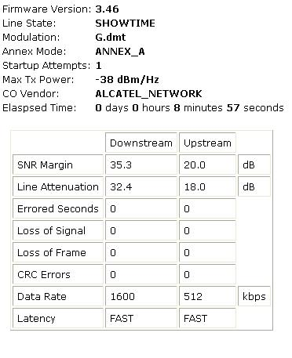
Showtime Firmware Version: This field displays the Conexant ADSL data pump
firmware version number.
ADSL Line Status: This field displays the ADSL connection process and status. When
Line State displays ‘Showtime’, the ADSL connection is available.
ADSL Modulation: This field displays the ADSL modulation status for G.dmt or
T1.413.
ADSL Annex Mode: This field displays the ADSL annex modes for Annex A or
Annex B.
ADSL Startup Attempts: This field displays the ADSL connection attempts after loss of
showtime.
ADSL Max Tx Power: This field displays the transmit output power level of the CPE.
ADSL CO Vendor: This field displays the Central Office DSLAM vendor name, if
available.
Elapsed Time: This field displays the time of the homestation has been in operation.
SNR Margin: Amount of increased noise that can be tolerated while maintaining the
designed BER (bit error rate). The SNR Margin is set by Central Office DSLAM. If the
SNR Margin is increased, bit error rate performance will improve, but the data rate will
decrease. Conversely, if the SNR Margin is decreased, bit error rate performance will
decrease, but the data rate will increase.
Line Attenuation: Attenuation is the decrease in magnitude of the ADSL line signal
between the transmitter (Central Office DSLAM) and the receiver (Client ADSL
Homestation), measured in dB. It is measured by calculating the difference in dB between the
signal power level received at the Client ADSL homestation and the reference signal power
level transmitted from the Central Office DSLAM.
Errored Seconds: The error during Showtime, whenever, a given sec contains CRC
error, that second will be declared error second.
Loss of Signal: This field displays the count of event of ADSL signal loss.
Loss of Frame: This field displays the count of event of ADSL frame loss.
CRC Errors: This field displays the number of transmit data frames containing CRC
errors.
Data Rate: This field displays the ADSL data rate.
Latency: This field displays the latency modes for fast or interleave.

5.5.3 WAN Status
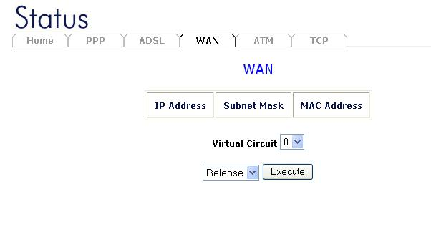
Each VC setting you enabled in the WAN Configuration section except those which use PPP encapsulation will be displayed in this table.

5.5.4 ATM Status
Display the status of ATM. (statistics between homestation and telephone central) This screen will automatically refresh every two seconds.
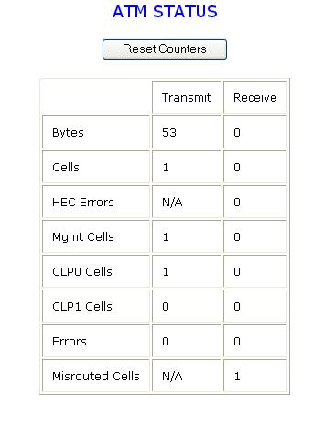

5.5.5 TCP Status
Display the status of TCP. (networking statistics) This screen will automatically refresh every two seconds.
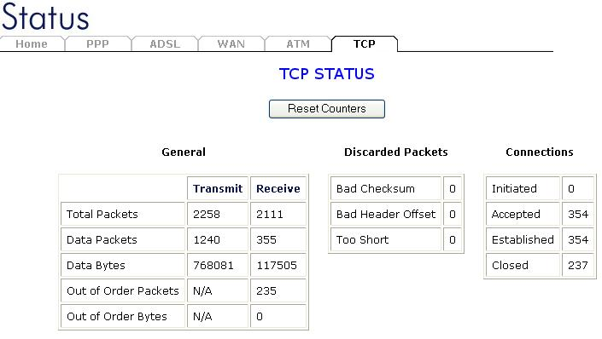

5.6 Configuration

5.6.1 WAN Configuration
This screen contains settings for the WAN interface. (In most cases you won’t have to configure manually. The configuration Utility from Chapter 4 takes care of all these settings)
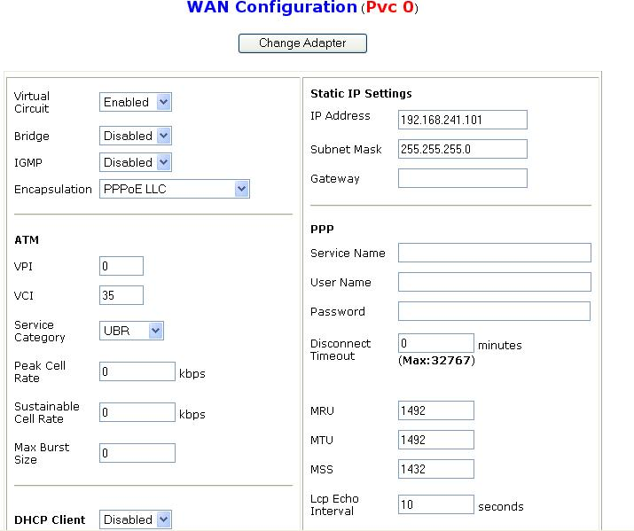
Per VC Settings
There are eight Virtual Circuits (VC) to set, VC 0 to VC 7. Before you make the settings, please scroll down to the bottom of the page and select the item of Virtual Circuit you want to configure. Then, press the Submit button.
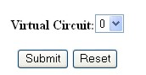
Virtual Circuit : Select Enabled if you want to enable the settings of this VC or select Disabled if you want to disable the settings of this VC.
VPI: Consult the ISP to get the Virtual Path Identifier (VPI) number. The default value is 0.
VCI: Consult the ISP to get the Virtual Channel Identifier (VCI) number. The default value is 35.
Static IP Address: Enter the information provided by your ISP.
Subnet Mask: Enter the information provided by your ISP.
Static Gateway: Enter the information provided by your ISP.
MAC SPOOFING
The MAC Spoofing is developed to solve the scenario when the ISP only recognizes one
MAC address. Copy the ISP-recognized MAC address here.
ATM
Service Category: Select UBR or CBR.
Bandwidth: Enter the bandwidth.
ENCAPSULATION
There are eleven connection protocols: PPPoE VC-Mux, PPPoE LLC, PPPoE None, PPPoA VC-Mux, PPPoA LLC, 1483 Bridged IP VC-Mux, 1483 Bridged IP LLC, 1483 Routed IP VC-Mux, 1483 Routed IP LLC, Classical IP over ATM, Native ATM
Check with your ISP which protocol is used.
BRIDGE
If you set this device to be bridge mode, select Enable; if not, please select Disable.
IGMP
You can Enable or Disable this function.
PPP
If your encapsulation is set to be PPPoE or PPPoA, the following fields must be entered.
Service Name: This item is for identification purpose. If it is required, your ISP will provide you the information. Maximum input is 31 alphanumeric characters.
Username: Enter the username provided by your ISP.
Password: Enter the password provided by your ISP.
Disconnect Timeout seconds: Auto-disconnect the ADSL Router when there is no activity on the line for a predetermined period of time. You can input any number from 0 to 32767. The default value is 0 seconds.
MRU: Maximum Receive Unit indicates the peer of PPP connection the maximum size
of the PPP information field this device can be received. The default value is 1492 and is
used in the beginning of the PPP negotiation. In the normal negotiation, the peer will
accept this MRU and will not send packet with information field larger than this value.
MTU: Maximum Transmission Unit indicates the network stack of any packet is larger
than this value will be fragmented before the transmission. During the PPP negotiation,
the peer of the PPP connection will indicates its MRU and will be accepted. The actual
MTU of the PPP connection will be set to the smaller one of MTU and the peer’s MRU.
The default is value 1492.
MSS: Maximum Segment Size is the largest size of data that TCP will send in a single IP
packet. When a connection is established between a LAN client and a host in the WAN
side, the LAN client and the WAN host will indicate their MSS during the TCP
connection handshake. The default value is 1432.
Authentication: When AUTO option is chosen, the PAP mode will run first then CHAP.
Automatic Reconnect: Check to enable this device to automatically re-establish the connection when disconnected by ISP.
DHCP
DHCP client enable: Check to enable the DHCP client function if you want the device to get an IP address automatically from your ISP.
Host Name: Enter the name of your work group.
 | All settings need to be saved and the device needs to be rebooted before the changes to take effect.

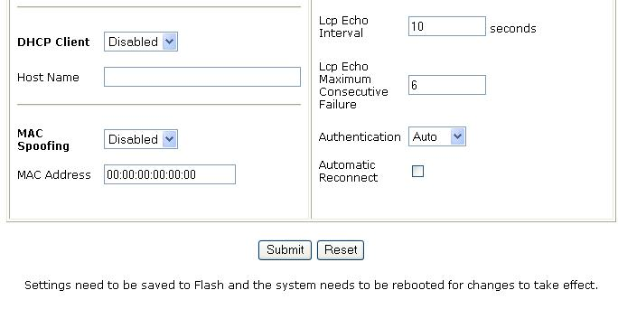

5.6.2 LAN Configuration
This screen contains settings for LAN interface.
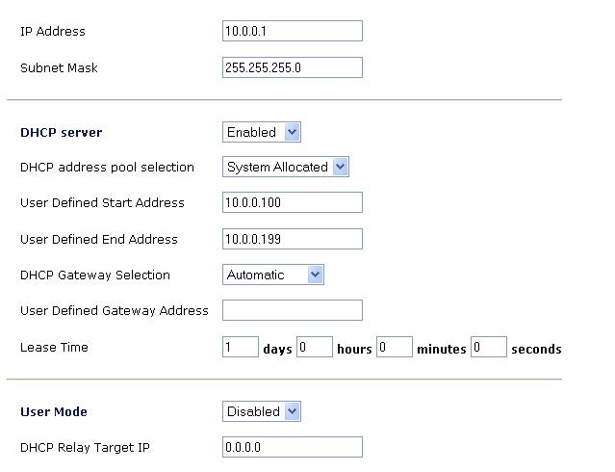
IP Address: Default at 10.0.0.1.
This is the device IP address in LAN site. If you plan to change it to another IP address to a different range of IP subnet. Please make sure your PC is also located at the same IP subnet. Otherwise, you may not be able to access the ADSL Router.
Subnet Mask: Default at 255.255.255.0.
DHCP Server
Check to enable the ADSL Router to distribute IP Addresses, subnet mask and DNS setting to computers. If you do not check to disable the ADSL Router to distribute IP addresses to the local network, remember to specify a static IP address, subnet mask, and DNS setting for each of your local computers. Be careful not to assign the same IP address to different computers.
If there is already a DHCP server on your LAN, you should disable the router’s DHCP server function in order to avoid possible conflicts.
DHCP address pool selection: Select System Allocated if you want the device to allocate the local IP network address pool automatically. Select User Defined if you would like to set your own IP addresses for distribution to PCs, and then enter your settings below.
User Defined Start Address: Enter the starting address of this local IP network address pool. The pool is a piece of continuous IP address segment. The default value is 10.0.0.100.
User Defined End Address: Enter the end address of this local IP network address pool. The default value is 10.0.0.199.
The local PC will get an IP address in this range, from 10.0.0.100 to 10.0.0.199.
Lease Time: Set the lease time you required. Lease time is the periode the Local PC will obtain the IP address it received from the DHCP server. After this periode the local PC will request a new IP from the DHCP server. If all fields are 0, the allocated IP addresses will be effective forever.
DHCP Gateway Selection: The default setting for the DHCP Gateway Selection is “Automatic”. The user can select the “User Defined” to specify “User Defined Gateway Address”. The DHCP server will issue the “User Defined Gateway Address” to the LAN DHCP clients.
User Mode: Under the Single User mode, the DHCP server only allocates one IP address
to local PC. Under the Multiple User mode, the DHCP server allocates the IP addresses
specified by the DHCP address pool.

5.6.3 NAT Configuration
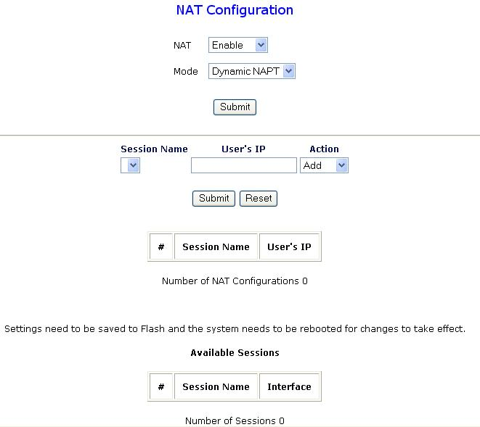

The NAT Configuration page allows the user to set the configuration for the Network
Address Translation. NAT feature allows multiple users to access Internet through a single IP account, sharing the single IP address from ISP.

The default setting is Dynamic NAPT. It provides dynamic Network Address Translation capability between LAN and multiple WAN connections, and the LAN traffic is routed to appropriate WAN connections based on the destination IP addresses and Route Table. This eliminates the need for the static NAT session configuration between multiple LAN clients and multiple WAN connections. When the Dynamic NAPT is chosen, there is no need to configure the NAT Session and NAT Session Name Configuration.
The NAT option only maps single WAN IP address to the local PC IP address. It is peer to-
peer mapping. (1x1) For each WAN interface, only one local PC IP address can be
associated with each WAN interface. Click the link Session Name Configuration to add
the session name for WAN interface.

The NAPT option maps the single WAN IP addresses to many local PCs IP addresses.
(1xN). It is the multiple-mapping mechanism. For each WAN Interface, more than one
local PCs can be associated with one WAN Interface. Click the link Session Name
Configuration to add the session name for WAN interface.

Session Name: This field allows the user to enter his/her own session Name to
distinguish different NAT session for different interfaces among different PPP sessions
and different PVCs.
Interface: This field allows the user to choose specific WAN Interface (PVC or PPP
Session) for NAT Session.
NAT Session Name Status: This table displays at the bottom of this page to show all
the NAT Session Names with its WAN Interface.
Number of NAT Configurations: This filed displays the total number of NAT Sessions
Name is entered.
Click the link Go back to NAT Configuration to the NAT configuration page. Select
the NAT option. Select the Session Name and assign the PC IP address, and choose the
Add action. Click the Submit button and go to the Save Settings to save this
configuration.
NAT allows only one entry (User IP) per session.
NAPT allows many entries (User IPs) per session.
Session Name: This field allows the user to select the session from the configured NAT
Session Name Configuration.
User’s IP: This filed allows the user to assign the IP address to map the corresponding
NAT/NAPT sessions.
Session Name Status will be displayed at the middle of this page to show the
corresponding Session Name with its IP address.
Number of NAT Configurations: This filed displays the total number of NAT Sessions
is entered.
Available Sessions Status will be displayed at the end of this page to show all the
Session Names with its WAN Interface.
Number of Session: This filed displays the total number of NAT Sessions Name is
entered.

5.6.4 Save Settings
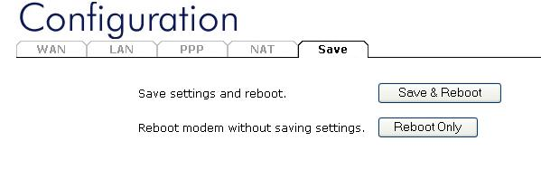
Click the Save & Reboot button to write settings to flash. Then, the system will reboot for changes to take effect.
Click the Reboot Only button to reboot the system without saving the settings.

5.7 Advanced

5.7.1 Virtual Server Configuration
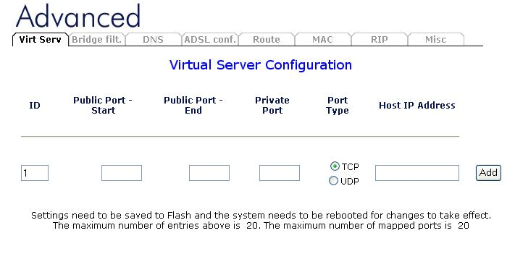
Being a natural Internet firewall, the ADSL Router protects your network from being accessed by outside users. When it needs to allow outside users to access internal servers, e.g. Web server, FTP server, E-mail server or News server, this product can act as a virtual server. You can set up a local server with specific port numbers that stands for the service, e.g. Web (80), FTP (21), Telnet (23), SMTP (25), POP3 (110), DNS (53), ECHO (7), NNTP (119). When an incoming access request to the router for specified port is received, it will be forwarded to the corresponding internal server.
For example, if you set the Public Port number 21 (FTP) to be mapped to the IP Address 10.0.0.100, then all the ftp requests from outside users will be forwarded to the local server with IP address of 10.0.0.100.
Public Port Start: Enter the public starting port number you want to configure.
Public Port End: Enter the public starting port number you want to configure.
Private Port: Enter the private port number you want to configure. In most cases, the private port number is same as public port number.
Port Type: Select TCP if you want to scope for the connection-based application service on the remote server using the port number. Or select UDP if you want to scope for the connectionless application service on the remote server using the port number.
Host IP Address: Enter the IP address of certain internal server to which requests from the specified port is forwarded.
If the DHCP server option is enabled, you have to be very careful in assigning the IP addresses of the virtual servers in order to avoid conflicts. The easy way is that the IP address assigned to each virtual server should not fall into the range of IP addresses that are to be issued by the DHCP server. You configure the virtual server IP address manually, but it is still in the same subnet with the router.

5.7.2 Bridge Filtering Configuration
The Bridge Filtering configuration page allows the user to set the configuration of IP
filtering.
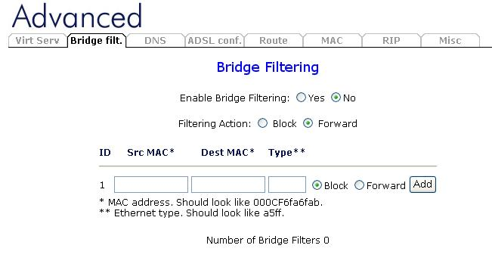
Enable Bridge Filtering: Check Yes to enable this function or check No to disable.
Source MAC: When the bridge filtering is enabled, enter the Source MAC address,
select Block and click Add. Then all incoming WAN and LAN Ethernet packets matched
with this source MAC address will be filtered out. If the Forward is selected, then the
packets will be forwarded to the destination PC.
Destination MAC: When the bridge filtering is enabled, enter the Destination MAC
address, select Block and click Add. Then all incoming WAN and LAN Ethernet
packets matched with this destination MAC address will be filtered out. If the Forward
is selected, then the packets will be forwarded to the destination PC.
Type: Enter the hexadecimal number for the Ethernet type field in Ethernet_II packets.
For example, 0800 is for IP protocol.

5.7.3 DNS Configuration
The DNS Configuration page allows the user to set the configuration of DNS proxy.
The firmware supports the DNS proxy function. For the DHCP requests from local PCs, the DHCP server will set the LAN port IP as the default DNS server. Thus, all DNS query messages will come into LAN port first. The DNS proxy on the ADSL homestation recorded the available DNS servers, and forward DNS query messages to one of DNS server.
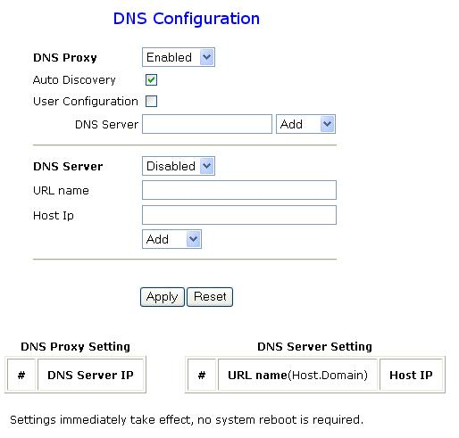
Disable DNS Proxy: The LAN port does not process the DNS query message. For the
DHCP requests from local PCs, the DHCP server will set the user-configured preferred
DNS sever or alternate DNS server whichever is available as the DNS server. Then all
DNS query messages will be directly sent to the DNS servers.
Auto Discovery: The DNS proxy will store the DNS server IP addresses obtained from DHCP client or PPP into the table. And all DNS query messages will be sent to one of the dynamically obtained DNS servers.
Use User Configuration: The DNS proxy will use the user-configured preferred DNS server and alternate DNS server. And all DNS query message will be sent to one of DNS servers. Enter the DNS IP in the Preferred DNS Server and Alternate DNS Server fields.
Auto Discovery + User Configured: The DNS proxy’s table has all the IP addresses of
dynamically obtained and user configured DNS servers.

5.7.4 ADSL Configuration
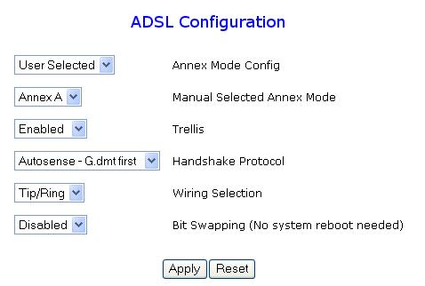
Annex Mode: Default at User Selected. You can also choose Autodetected.
Manual Selected Annex Mode: You can choose either Annex A, or Annex B.
Handshake Protocol: Default at Autosense – G.dmt first. You can also choose other protocols, such as Autosense – T1.413 first, G.dmt/G.lite, T1.413, G.dmt, G.lite.
Trellis: Default at Enabled.
Wiring Selection: Default at Tip/Ring. Select Auto or A/A1 if necessary.
Bit Swapping: This field allows the user to enable or disable the upstream bit swapping.

5.7.5 Route Table
The Route Table page displays routing table and allows the user to manually enter the
routing entry. The routing table will display the routing status of Destination, Netmask,
Gateway, and Interface. The interface br0 means the USB interface; lo0 means the
loopback interface; and ppp1 means the PPP interface. The Gateway is the learned
Gateway

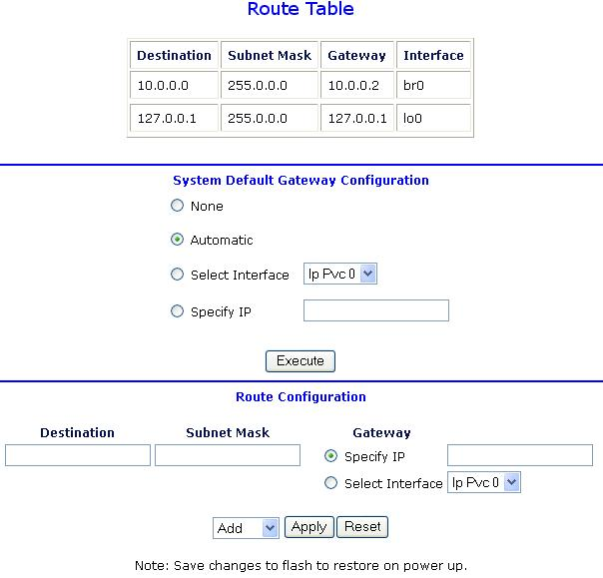

New Enhancement for Routing Table

• The Gateway field of the static route entry allows users to either enter a Gateway IP
address or select a Network Interface.
• All user-defined routes retained in the CPE memory, regardless if they are already in the
Routing Table, are displayed on the same Route Table page.
• All user defined route entries kept in the CPE memory during run time are saved to flash
when the user chooses to save and reboot the CPE. When CPE restarts, it reloads all
saved user-defined routes to the CPE memory and tries to apply to the system.
• A user-defined route entry is added to the Routing Table whenever the system provides
an environment that makes the route entry applicable. It is removed from the Routing
Table whenever the route entry becomes not applicable. e.g. If the route entry’s Gateway
is associated with a dynamic Network Interface but the connection is not established, then
the route entry does not appear in the Routing Table. When that interface comes up later,
the route entry is then added.
• If the selected Network Interface is static or is dynamic and the connection is already up,
then the route entry appears in the Routing Table immediately. If there is a Gateway
associated with the selected Network Interface, then that Gateway’s IP address appears in
the Gateway field of the route entry
• If the selected Network Interface is dynamic but the connection is not established, then
the route entry does not appear in the Routing Table. When the interface comes up later,
the route entry is then added.

System Default Gateway Configuration

The system-wide Default Gateway now provides three options: Auto, User-selected
Network Interface, and None.
None: This field allows the user to choose to have no Default Gateway in the CPE
Auto: This field allows the user to select the CPE to automatically decide the Default
Gateway. (System Default)
User-selected Network Interface: This field allows user to select a Network Interface
from a list (PVCs, PPP Sessions, USB and LAN). This option lets the user to associate
the system-wide Default Gateway to a Network Interface, static or dynamic, and provides
a way to fix the Default Gateway to a dynamic Network Interface before the interface is
established.

Route Configuration

Destination: This field allows the user to enter the remote network or host IP address for
the static routing.
Netmask: This field allows the user to enter the Subnet Mask for the static routing.
Gateway: This field allows the user to enter the IP address of the gateway device that
allows the router to contact the remote network or the host for Specified IP or select an
Interface for the Gateway.
Manually Configured Routes: This field displays the static route entries entered by the user

5.7.6 Learned ( Bridge ) MAC Table
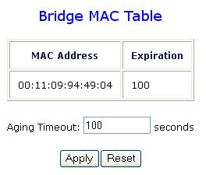
Aging Timeout: Enter the time period for the router to memorize MAC addresses.

5.7.7 RIP Configuration
The Routing Information Protocol, enables routers to broadcast and receive information to and from other routers about which routers it’s connected and the steps it requires to get there. A router will changes it’s routing table if it receives information it could reach a specific router faster.
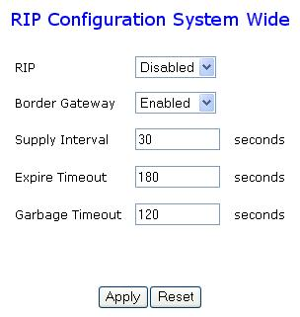
RIP: This field allows the user to Enable or Disable the RIP session. The resulting RIP
session will monitor all network interfaces that are currently available for messages from
other RIP routers.
Supplier Interval: This field allows the user to enter the Supplier Interval timer in
second. This timer specifies how often RIP sends announcements as a RIP Supplier.
(Default = 30 seconds)
Expire Timeout: This field allows the user to enter the Expire timer in second. This
timer specifies the expiration time of a route. When a route has not been updated for
more than “expire” period of time, it is removed from the Route Table. This route is
invalidated and remains in the internal RIP Route Table. It will be included in the RIP
announcements to let other routers know the changes. (Default = 180 seconds)
Garbage Timeout: This field allows the user to enter the Garbage timer in second. This
timer specifies how long the expired and invalidated routes are kept in the Internal RIP
Route Table before it is removed from it. (Default = 300 seconds)

The RIP Per Interface Configuration page allows the user to set the configuration for each Interface (PVCs, PPP Sessions, USB and LAN).
Interface: This field allows the user to choose the Interface (PVCs, PPP Sessions, USB
and LAN), for the RIP to be configured.
Enable: This field allows the user to Enable (Yes) or Disable (No) the specified
interface for RIP.
Supplier: This field allows the user to select the Supplier Mode (RIP Transmit).
• Disabled: The supplier transmit is disabled.
• V1 BC: The supplier transmits in RIPv1 Broadcast.
• V2 BC: The supplier transmits in RIPv2 Broadcast.
• V2 MC: The supplier transmits in RIPv2 Multicast.
Listener: This field allows the user to select the Listener Mode (RIP Receive)
• V1: The listener receives the RIPv1 only.
• V2: The listener receives the RIPv2 only.
• V1+V2: This listener receives the both RIPv1 and RIPv2.
Supplier and Listener are based on section 4.1 “Compatibility Switch” in RFC 1723.
Current RIP Settings: This field displays the each interface’s RIP status.

5.7.8 Miscellaneous Configuration
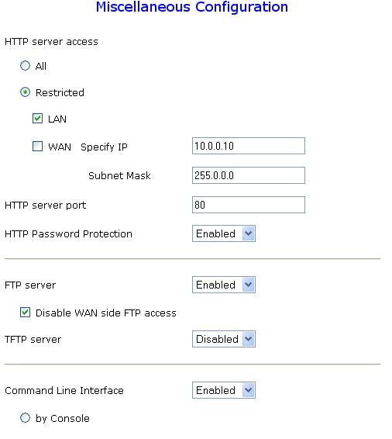
HTTP Server Access: This field allows the user to configure the Web pages can be
accessed from WAN
All: When this field is checked, it allows both WAN and LAN access to the Web pages.
Restricted LAN: This field allows the Web pages access from LAN side.
Restricted WAN Specified IP & Subnet Mask: This field allows the Web access from
WAN side with a specify IP and subnet mask.
HTTP Server Port: This field allows the user to specify the port of the Web access. .
For example, when it is changed to 1001, the HTTP server address for the LAN side is
http://10.0.0.1:1001.
FTP server: This field allows the user to enable or disable the FTP connection.
TFTP server: This field allows the user to enable or disable the TFTP connection.
DMZ: A DMZ (De-Militarized Zone) is added between a protected network and an
external network, in order to provide an additional layer of security. When there is a
suspected packet coming from WAN, the firewall will forward this packet to the DMZ
host.
DMZ Host IP: The IP address of the DMZ host at LAN side.
IGMP Proxy: Here is the global setting for IGMP Proxy. If it is enabled, then the
enabled IGMP Proxy on WAN PVCs will be working. Otherwise, no WAN PVC can
have IGMP Proxy working on it.
PPP connect on WAN access: If it is enabled, the PPP session will be automatically
established when there is a packet wants to go out the WAN.
PPP Half Bridge: When the PPP Half Bridge is enabled, only one PC is able to access
the Internet, and the DHCP server will duplicate the WAN IP address from the ISP to the
local client PC. Only the PC with the WAN IP address can access the Internet.

Connect PPP on WAN access: if PPP on WAN access is enabled, the ADSL router will automatically reconnect when an URL is entered in the browser.

Connect PPP when ADSL link is up: when selected, the ADSL router will automatically reconnect when the ADSL line is active.

SNTP: Here the time zone can be selected, and the IP address for an internet time server can be set.

ADSL Status refresh rate: select the refresh rate of the ADSL status page in the ADSL router.

USB: when enabled, the ADSL router can also be connected via USB.

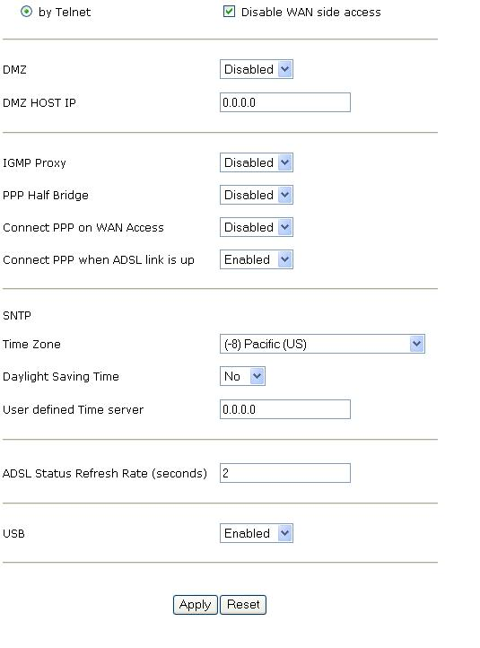

5.8 Admin

5.8.1 Password Configuration
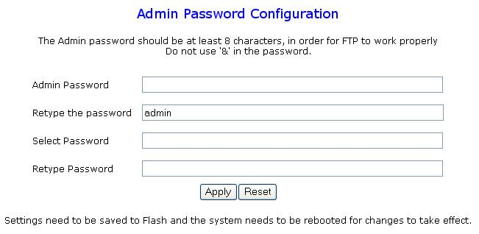
In factory setting, the default password for administrator is password, and that for user is also password. You can change the default password to ensure that someone cannot adjust your settings without your permission. Every time you change your password, please record the password and keep it at a safe place.
Please note that the minimum input for password is 8 alphanumeric characters. Since it is case sensitive, be sure that you remember whether a letter is in upper or lower case and make sure that your Caps Lock is off. Moreover, please do not use the sign “&” in the passwords.

5.8.2 Reset to Factory Default
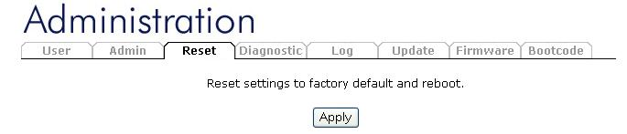
With the apply button, the router will be reset to it’s default settings, described in chapter 5.1. Be carefull, all your settings will be lost.

5.8.3 Diagnostic Test
As soon as you enter the test program, all tests will run automatically to diagnose the connection status of the device.
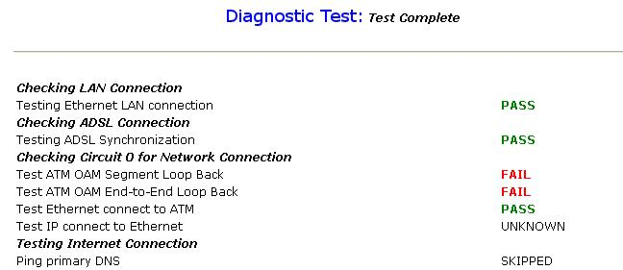
Checking LAN Connection
Testing Ethernet LAN connection
This test passes if the Ethernet LAN interface is working properly.
Checking ADSL Connection
Testing ADSL Synchronization
This test checks your DSL homestation to see if it can successfully negotiate and establish a DSL connection with your service provider's central office equipments. The test returns PASS if a DSL connection is established.
If this test returns FAIL, please try the test again a few minutes after this test is completed. Since your DSL homestation need a couple of seconds to a few minutes to establish the DSL connection depending on your phone line quality. If this test returns FAIL, make sure your phone line is connected to your DSL homestation securely, and also check with your service provider to see if your service is activated.
If this test returns FAIL, all other tests will be skipped.
Checking Circuit 0 for Network Connection
Test ATM OAM Segment Loop Back
This test sends ATM OAM F5 Segment loop back request cells to the central office equipments through your DSL connection. This test will pass if response cell is received. Since your service provider might not support this test, your DSL homestation could still work even if this test fails.
If this test fails consistently and your DSL homestation seems not working, check to make sure the VPI and VCI are configured correctly.
This test returns FAIL if the DSL synchronization test failed.
Test ATM OAM End-to-End Loop Back
This test sends ATM OAM F5 End-to-End loop back request cells to the central office equipments through your DSL connection. This test returns PASS if response cell is received. Since your service provider might not support this test, your DSL homestation could still work even if this test fails.
If this test return FAIL consistently and your DSL homestation seems not working, check to make sure the VPI and VCI are configured correctly.
This test returns SKIPPED if the DSL synchronization test failed.
Test Ethernet connect to ATM
This test returns PASS if the ATM AAL5 module is loaded correctly in your DSL homestation. If this test returns FAIL, an internal error has occurred.
This test returns SKIPPED if the DSL synchronization does not return PASS.
Test PPPoE connection
This test returns PASS if your login name and password have passed authentication with your service provider.
If this test returns FAIL, run this test again a few minutes after this test is completed, especially if your PPP connection has just been improperly disconnected. If this test consistently fails, first make sure your login name and password are correct. Remember that login name and password are case sensitive.
This test returns SKIPPED if “PPPOE connect to Ethernet” test does not return PASS and your DSL homestation is configured as PPPOE encapsulation.
This test also returns SKIPPED if “Ethernet connect to AAL5” test does not return PASS and your DSL homestation is configured as PPPOA encapsulation.
Test PPP Layer connection
This test returns PASS if your DSL homestation has been assigned a valid IP address by your service provider through DHCP or your DSL homestation is assigned a valid IP address statically.
If this test returns FAIL, run this test again a few minutes after this test is completed. If this test returns FAIL consistently and DHCP client is turned on in your DSL homestation, check with your service provider. If this test returns FAIL consistently and your DSL homestation is statically assigned an IP address, make sure the IP address is the correct one assigned by your service provider.
This test returns SKIPPED if “Ethernet connect to AAL5” test does not return PASS.
Test IP connect to PPP
This test returns PASS if your DSL homestation has been assigned a valid IP address by your service provider through DHCP or your DSL homestation is assigned a valid IP address statically.
If this test returns FAIL, run this test again a few minutes after this test is completed. If this test returns FAIL consistently and DHCP client is turned on in your DSL homestation, check with your service provider. If this test returns FAIL consistently and your DSL homestation is statically assigned an IP address, make sure the IP address is the correct one assigned by your service provider.
This test returns SKIPPED if “Ethernet connect to AAL5” test does not return PASS.
Test IP connect to Ethernet
This test returns PASS if the gateway can be reached through ping request. The gateway is assigned by your service provider, or obtained from your service provider by PPP negotiation or DHCP negotiation.
If this test returns FAIL, run this test again a few minutes after this test is completed. If this test returns FAIL consistently and your DSL homestation seems not working, check to make sure your statically assigned IP address is configured correctly or DHCP client is turned on with the current VC.
This test returns SKIPPED if "IP connect to PPP" or "IP connect to Ethernet" test does not return PASS.

5.8.4 System Log
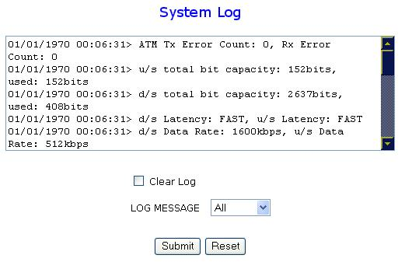
Display the system logs cumulated till the present time. You can trace the historical information through this function. It refreshes every two seconds.

5.8.5 Network Code Image Update
The Network Code Image Update page allows the user to upgrade the image code from
a remote FTP server.
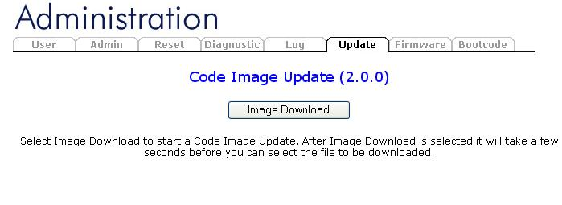

5.8.6 Firmware Update
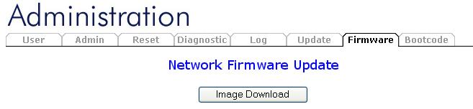
To upgrade the firmware of the ADSL Router, you should download or copy the firmware to your local environment first. First press ‘Image Download’ to initiate the Firmware Upgrade Mode. Press the “Browse…” button to specify the path of the firmware file. Then, click “Upload” to start upgrading. When the procedure is completed, please reboot the device to make the new firmware work.

5.8.7 Bootcode Update
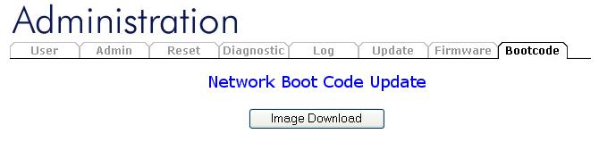
To upgrade the bootcode of the ADSL Router, click ‘Image Download’. The upgrade will be initiated, and the bootcode image will be downloaded from the internet. After the upgrade is completed, the ADSL router will reboot.

6. Trouble shooting
If the ADSL Router is not functioning properly, you can refer first to this chapter for simple troubleshooting before contacting your service provider. This could save your time and effort but if the symptoms persist, then consult your service provider.

6.1 Problems Starting Up the ADSL Router
Problem |  | Corrective Action
None of the LEDs are on when you turn on the ADSL Router. | Check the connection between the adapter and the ADSL Router. If the error persists, you may have a hardware problem. In this case, you should contact technical support.

6.2 Problems with the WAN Interface
Problem |  | Corrective Action
Initialization of the PVC connection failed. | Ensure that the cable is connected properly from the ADSL port to the wall jack. The ADSL SYN LED on the front panel of the ADSL Router should be on. Check that your VPI, VCI, type of encapsulation and type of multiplexing settings are the same as what you collected from your telephone company and ISP.  Reboot the ADSL Router. If you still have problems, you may need to verify these variables with the telephone company and/or ISP.

6.3 Problems with the LAN Interface
Problem |  | Corrective Action
Can’t ping any station on the LAN. | Check the LAN LNK LED on the front panel. The LED should be on for a port that has a station connected. If it is off, check the cables between your ADSL Router and the station.
Can’t ping any station on the LAN. | Verify that the IP address and the subnet mask are consistent between the ADSL Router and the workstations.

6.4 Problems Connecting to a Remote Node or ISP
Problem |  | Corrective Action
Can’t connect to ISP. | Check 5.5.2 Status – ADSL Status to verify the line status.

7. Specifications

Protocols | IP, NAT, NAPT, PPPoE, PPPoA, IPoA, DHCP, ICMP, IGMP, PAP, CHAP
LAN Port | RJ-45, 1 port 10/100Base-T
WAN Port | RJ-11, 1 ADSL port to external DSL/Cable Homestation, or other network equipment
USB Port | 1.1 slave interface
LED Indicators | SYS, ADSL RD, ADSL TD, ADSL SYN, LAN LNK, LAN ACT, PWR
Input Power | 9V DC @1A
Physical Dimension | 181 x 122 x 41 mm³ (L x W x H)
Weight | 300g
Operating Temperature | 0 ºC to 45 ºC
Storage Temperature | -10 ºC to 70 ºC
Relative Humidity | 5% to 95% non-condensing

